PROPOSE SOUTHEAST FIELD LAYOUT

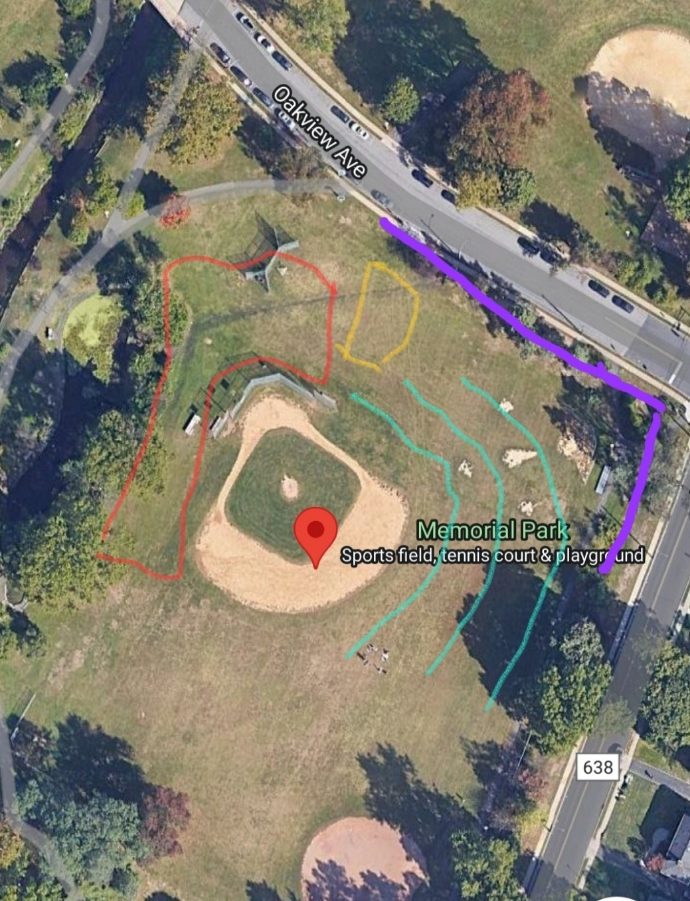

RED = KIDS ZONE
YELLOW = BEER GARDEN
PURPLE = FOOD VENDORS
GREEN = ART VENDORS

