# «First_Name_» «Last_Name»

The Garden State Chapter of ASHI

Presents this certificate to

«First_Name_» «Last_Name»

For the successful completion of a seminar on the topics of

Report writing & defect recognition

And is awarded 2 **ASHI MRC’s** and *2 **New Jersey CEU’s**

Given on December 10, 2020 in Virtual Meeting

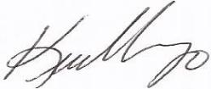

Kevin Vargo

President

* Contributes to State of New Jersey HIAC continuing education requirements for report writing (Pursuant to N.J.A.C. 13:40-15.2)