Maplewoodstock Responsibilities
Tom Kerns

Here are the specific tasks that I have performed over the past few years:

- Creation of initial budget (with Gary/Brad) - October
  - Use actual P&L from prior year as baseline
  - Submit budget at October meeting for committee approval.
- Apply for Social Affairs permit – Late January/Early February
  - Brad took care of this in 2024 and should continue to do so for future festivals.
- Apply for Event Permit/Field reservation with Township – Late February
  - Township Clerk – Liz Fritzen: lfritzen@maplewoodnj.gov
  - Application example – Appendix I
- Apply for Liability Insurance - Early/mid March
  - Phoenix Insurance Group
    - James Venezia - jvenezia@phxins.net
    - Eric Furrer - efurrer@phxins.net
  - Insurance must include the Township of Maplewood as additional insured.
  - Appendix II
- Liaison with Maplewood Township Committee and MWS Liaisons
  - Schedule and run meeting with Township department heads - April
    - Send agenda, Social Affairs permit & COI
Example - Appendix III
    - Send proposed police/security requirements
Example – Appendix IV

  - Be the contact for “all things Maplewood Township”, including any concerns and questions that arise (e.g., Memorial Park Conservancy)
- Create (with committee input) a Press Release for Village Green announcing the headliners, dates, etc!
- Monthly Meeting Agendas and follow up
- Headliner planning (assisting Tarquin)
  - Communicate payment requirements to Gary/Brad
- Headliner contract negotiations (business/legal)
  - Signatory for all contracts
- Negotiate (along with Tarquin) the contract with the production company.
  - Signatory on the contract
- Band selection -Member of the Band Selection Committee
  - Jim to create and send to the Band Selection Committee the detailed spreadsheet of band applications and download all the submitted MP3s.
  - Review/listen to/research all submissions and create a list of my top 25 picks.
  - Schedule and participate in Band selection day – Late April.
  - Creation of band line-up
    - Examples: Appendix V
  - Using the email addresses from the band’s applications, communicate selection/waitlist/rejection to the bands.
    - Examples: Appendix VI
  - Coordinate Band Meeting
    - Send Agenda/Stage plot template/Parking Access pass
    - Examples: Appendix VII
  - Collect Stage Plots and send to production company
  - Collect Setlist/Lyrics and send them to Laurellie/ASL interpreters.
    - Quite frankly this is a PIA! Must constantly remind bands to send the set list/lyrics. Some bands do not know what their setlists will be until right before the weekend/especially headliners.
    - Coordinate with Tarquin to request from the headliners.
- Schedule Announcements and MC’s for event
  - Example: Appendix VIII
- Day of
  - Manage Band flow with production company
  - MC some of the bands (SOMEONE NEEDS TO STEP UP HERE)
  - Introduce the Committee on Sunday evening!
  - Liaise with DPW – for all DPW related issues.
  - MAKE SURE EMERGENCY ACCESS LANES ARE PLANNED FOR
  - As mundane as this may seem it is important: Coordinate light stands with DPW
    - Coordinate turning on, the light stands each night
      - Vendor Village – 8:30pm (assuming the festival is still in July)
      - Amphitheater – Immediately after the final song (and not before).
      - Must be in phone/text communication with coordinating DPW personnel.
- Post event
  - Send thank you email to all appropriate Township departments
    - Example: Appendix IX
  - Create (with committee input) a Press Release Recap/Thank you!
With regard to the concept of a “Chair”…..

We have been calling this role the “Chair” since Gary was in the position. That may still be appropriate (for PR purposes), but I believe the title is secondary to the actual responsibilities.

What makes our MWS Committee so successful is that we all “know our lanes” and do what needs to be done. With a small committee of only 8 people, it is imperative that this is the case. Sometimes, however, managing by committee comes to an impasse and an executive decision needs to be made, or a gentle push may be required. In those rare times I have attempted to be the deciding vote on whatever the issue, and I believe I have been diplomatic and have tried to keep the overall mission of our festival in mind. In addition, here are some thoughts regarding the “Chair specific” tasks. (I have incorporated some of Jim’s thoughts in this):
- With regards to Township Liaison…
In addition to the operational requirements as stipulated above, the Chair is the point person for “all things Maplewood Township”, including questions and concerns from the different departments (Police/DPW/etc).
- Public Relations
  - Be the point person for all press inquiries.
  - Coordinate with the committee on responses to all “issues” (such as the Bible Church incident in 2023)
  - Create (with committee input) and submit all press releases (Jim has done much of this as well)
- Manage each planning meeting
  - Set the agenda
  - Send reminders about all meetings
  - Keep the meeting on point
  - (Gently) Hold committee members accountable for assigned tasks
- Intangibles
  - Be the calming influence.
  - Ameliorate any burgeoning issues (using my SAT words). In essence, ensure that all voices are heard before a final decision is made.
  - Must be the CALM AND RESPECTFUL (but firm, if necessary) representative with the Township.
  - Have one-on-one discussions with Committee members who may be having an issue(s) with process or discussion points.

My recommendations:

Many of the specific tasks that I have taken on as outlined above can be done by anyone, so I leave it to the committee to decide who takes on what, however there are some that will require a “Chair”, or “Co-Chair”, or “Chair/Vice Chair”. These include:
- Contract signing
- “Face” of the committee
  - Meeting/Liaison with Township
  - Public/Press inquiries and concerns.
- Meeting planning and management, and
- The intangibles

For these specific tasks (and others depending on the committee’s view) I believe Susan and Brad would be the appropriate people to take on these specific tasks as co-chairs.

APPENDIX I

MAPLEWOOD EVENT APPLICATION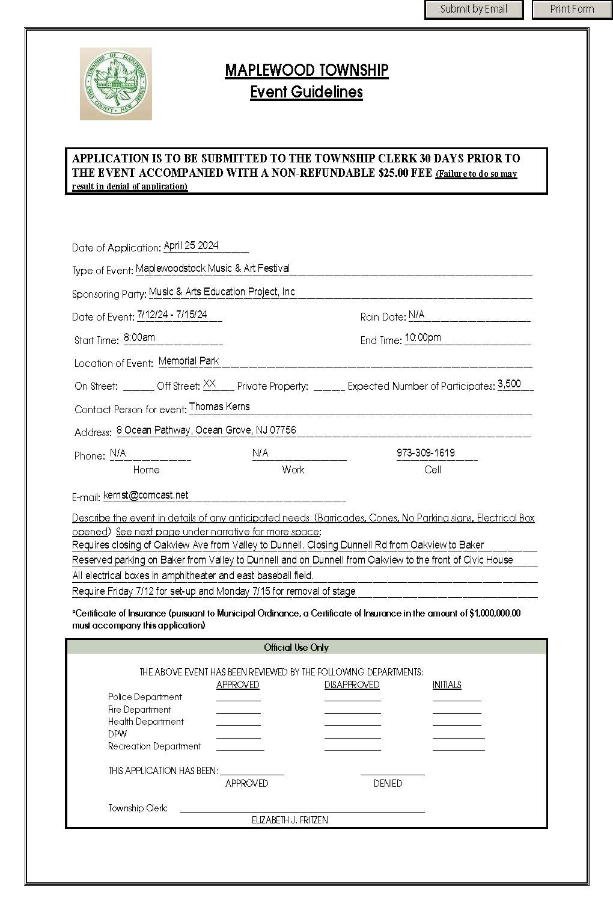
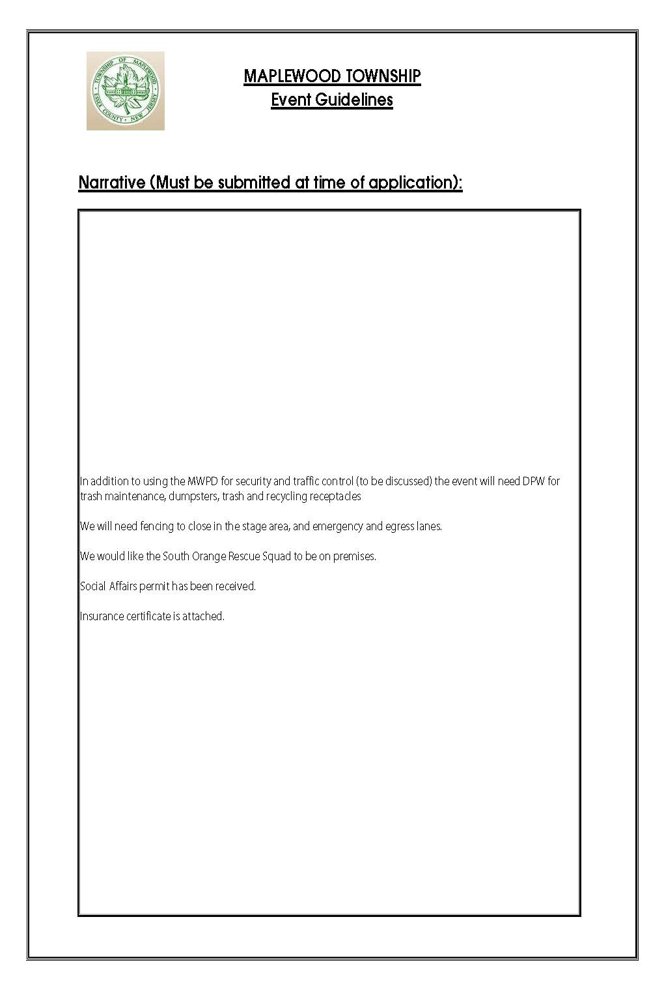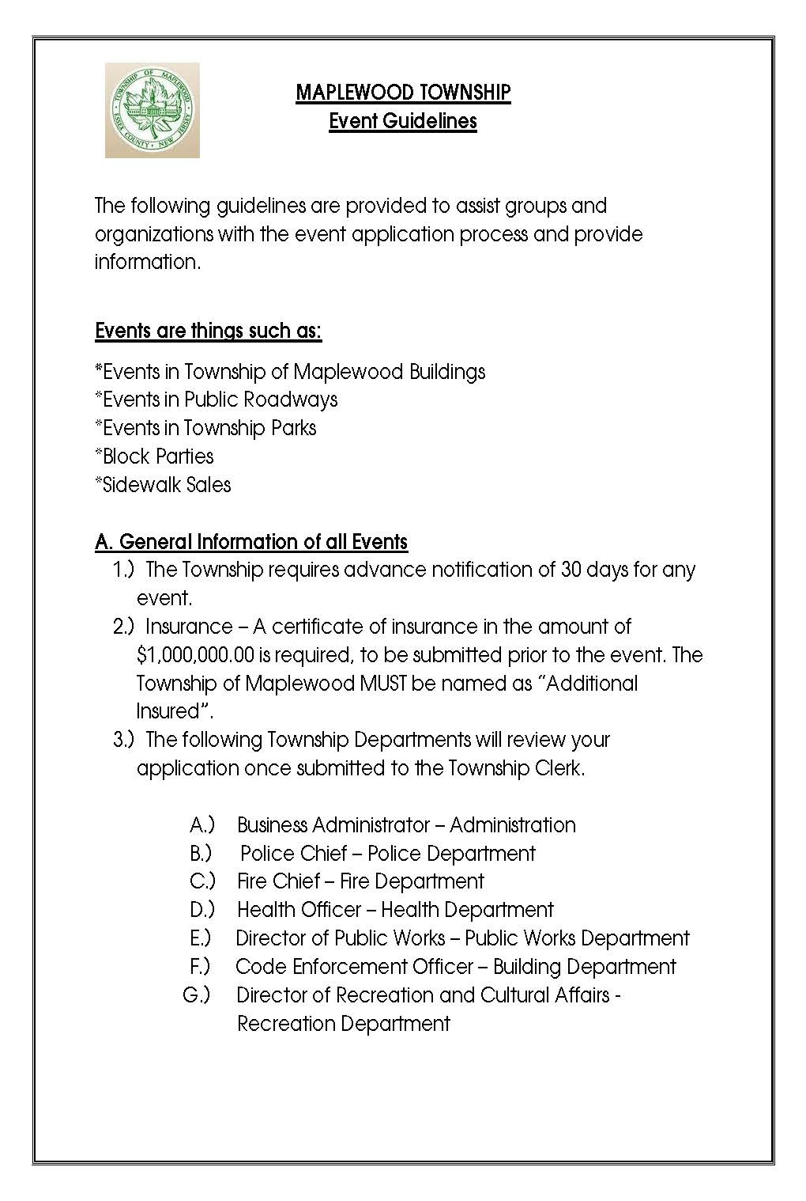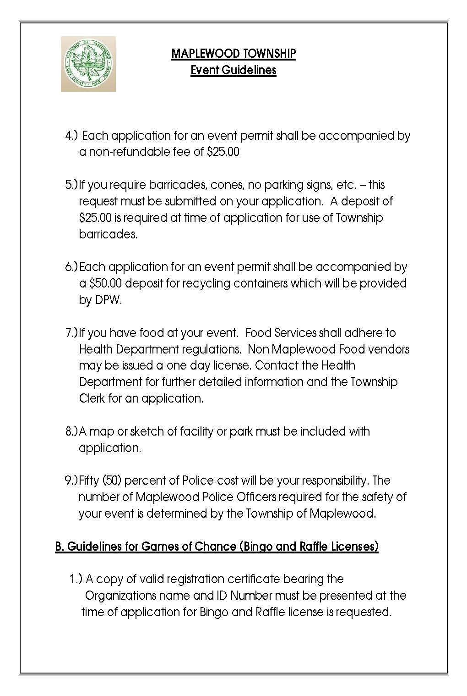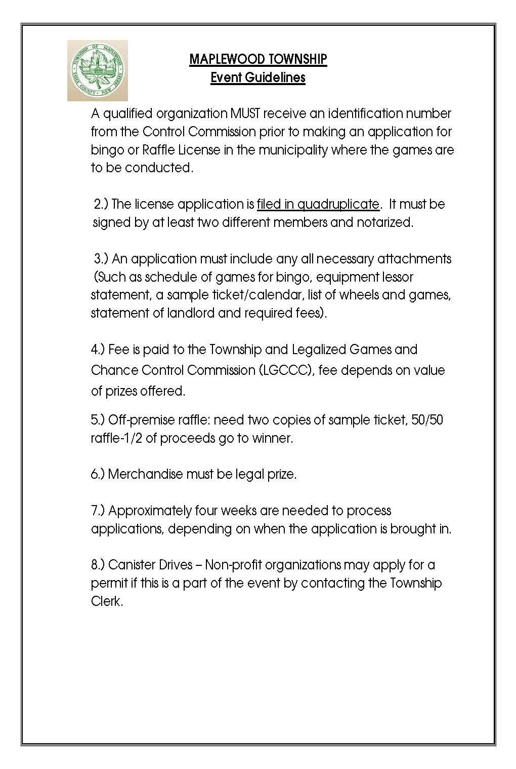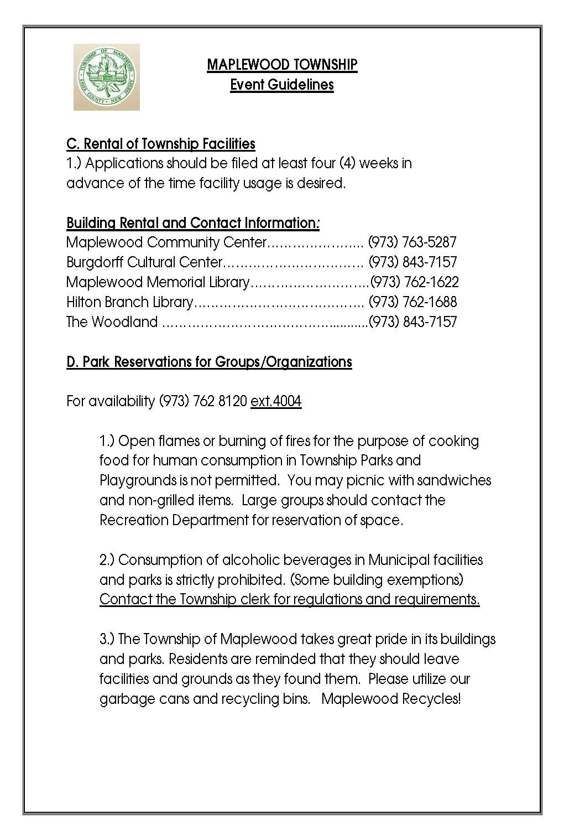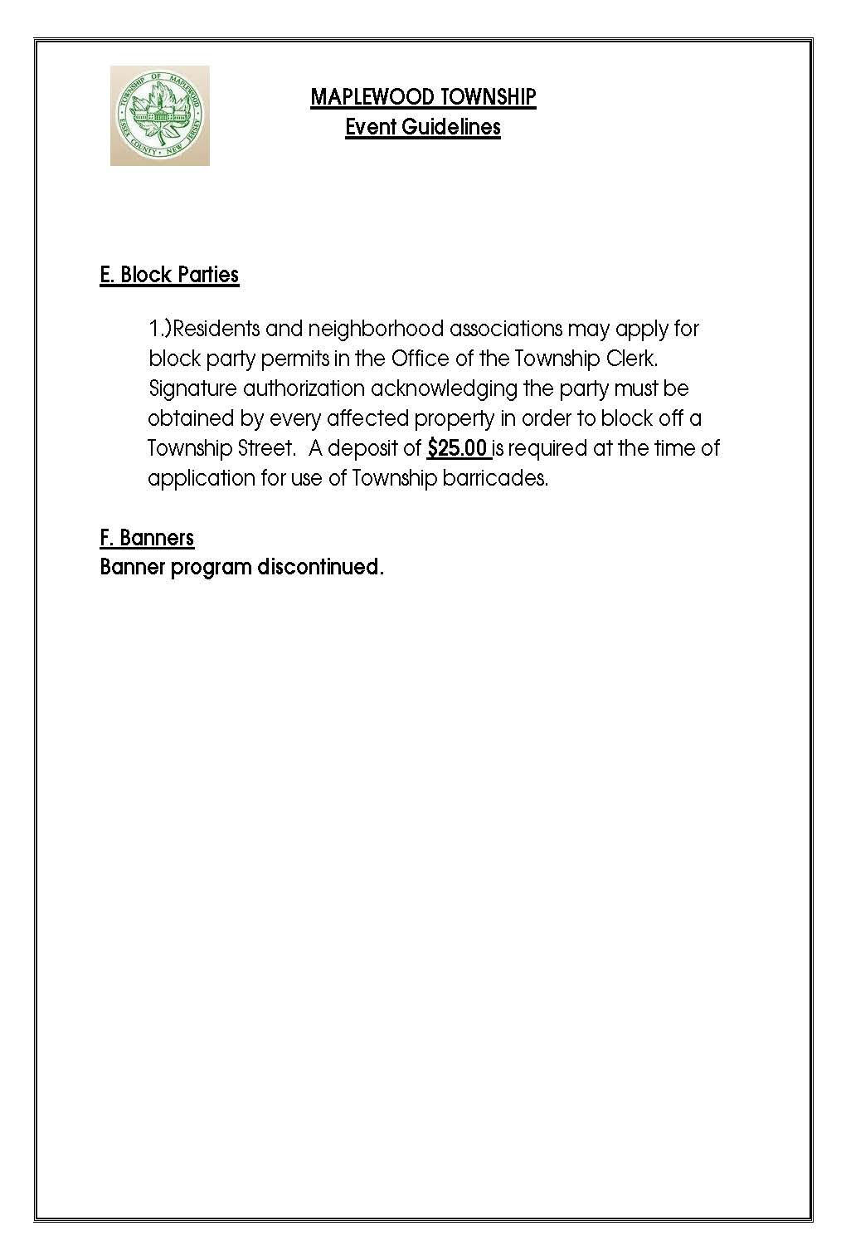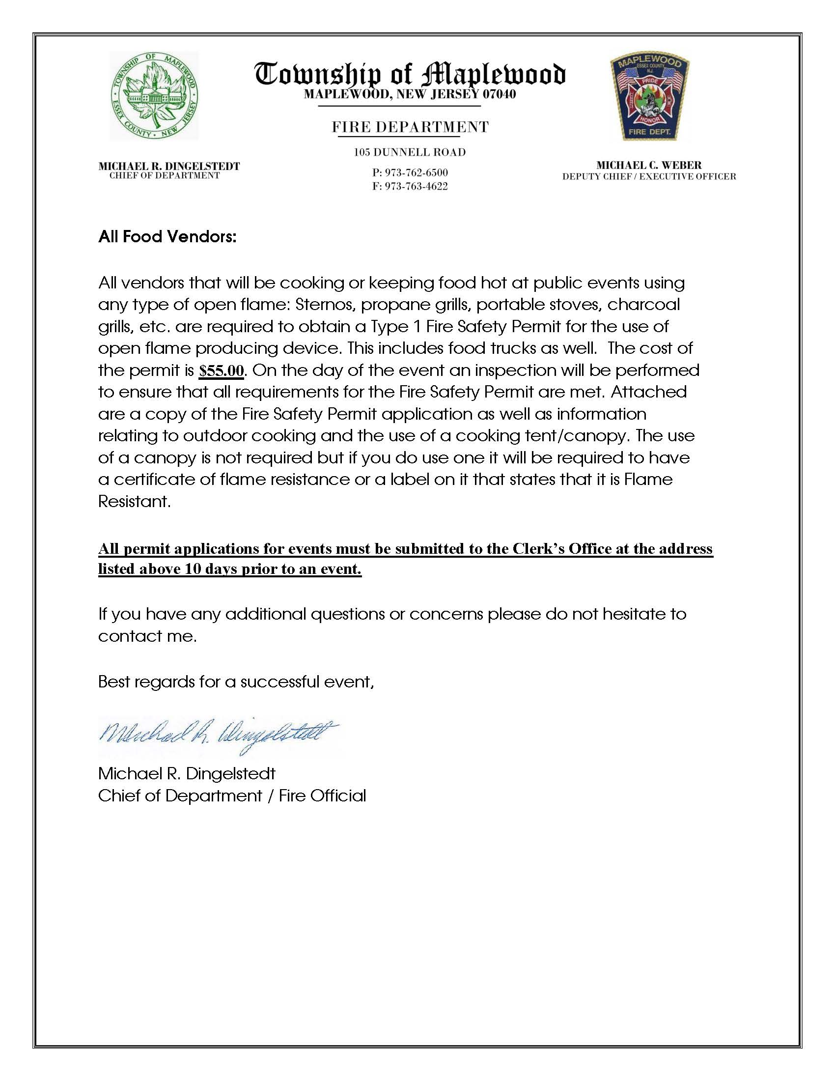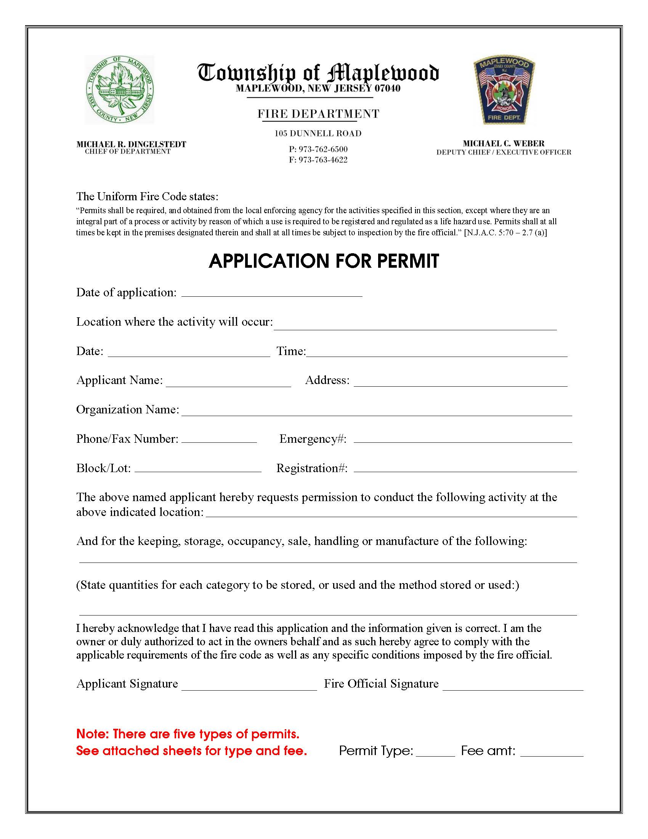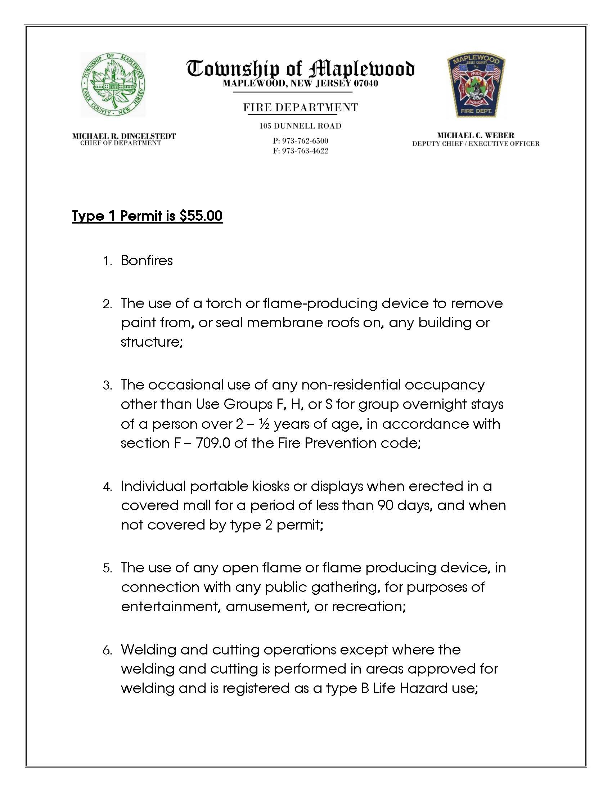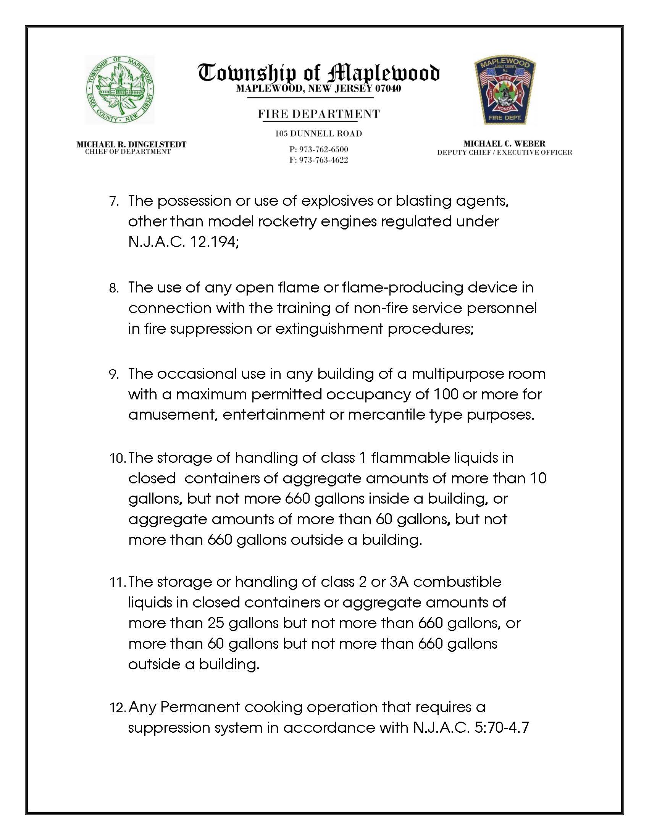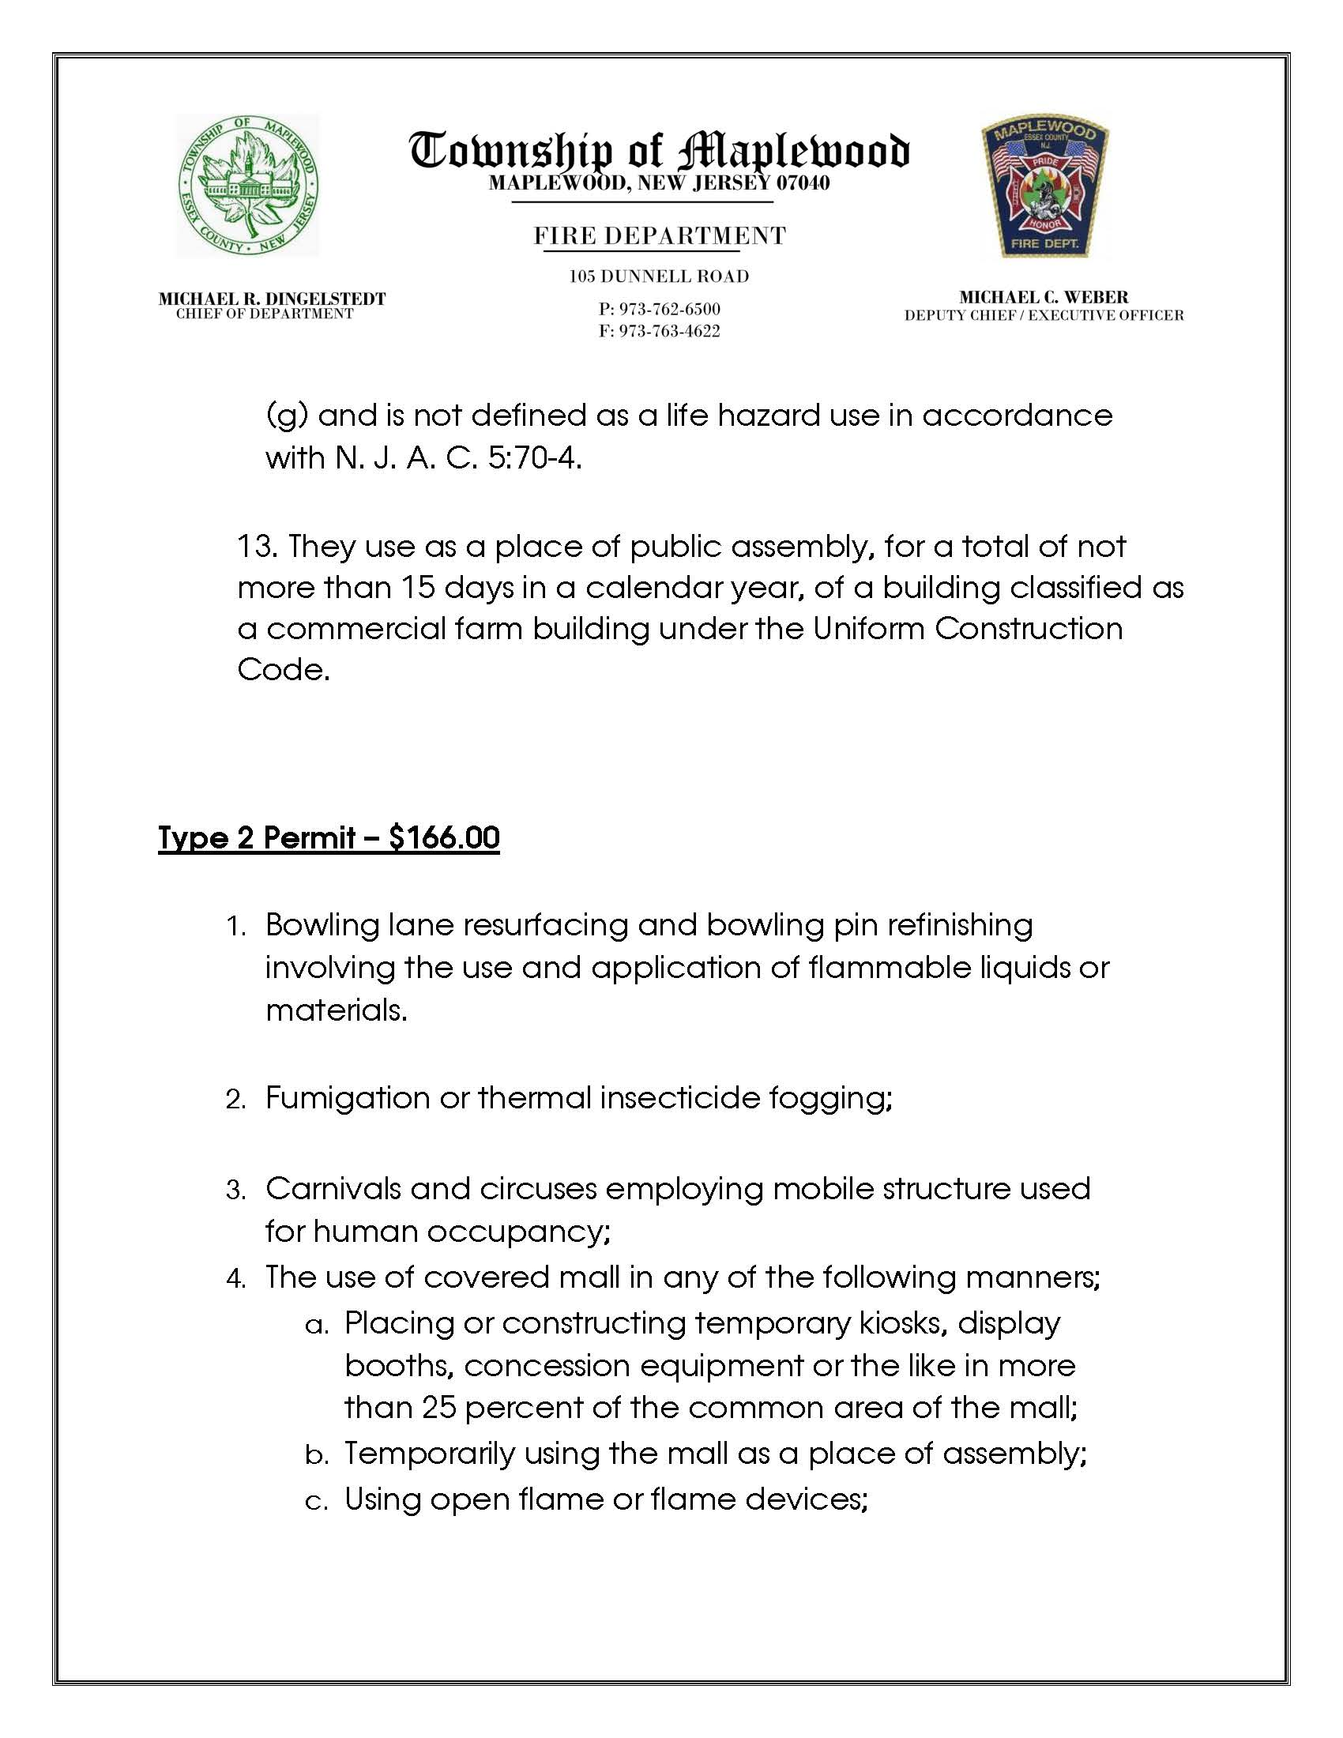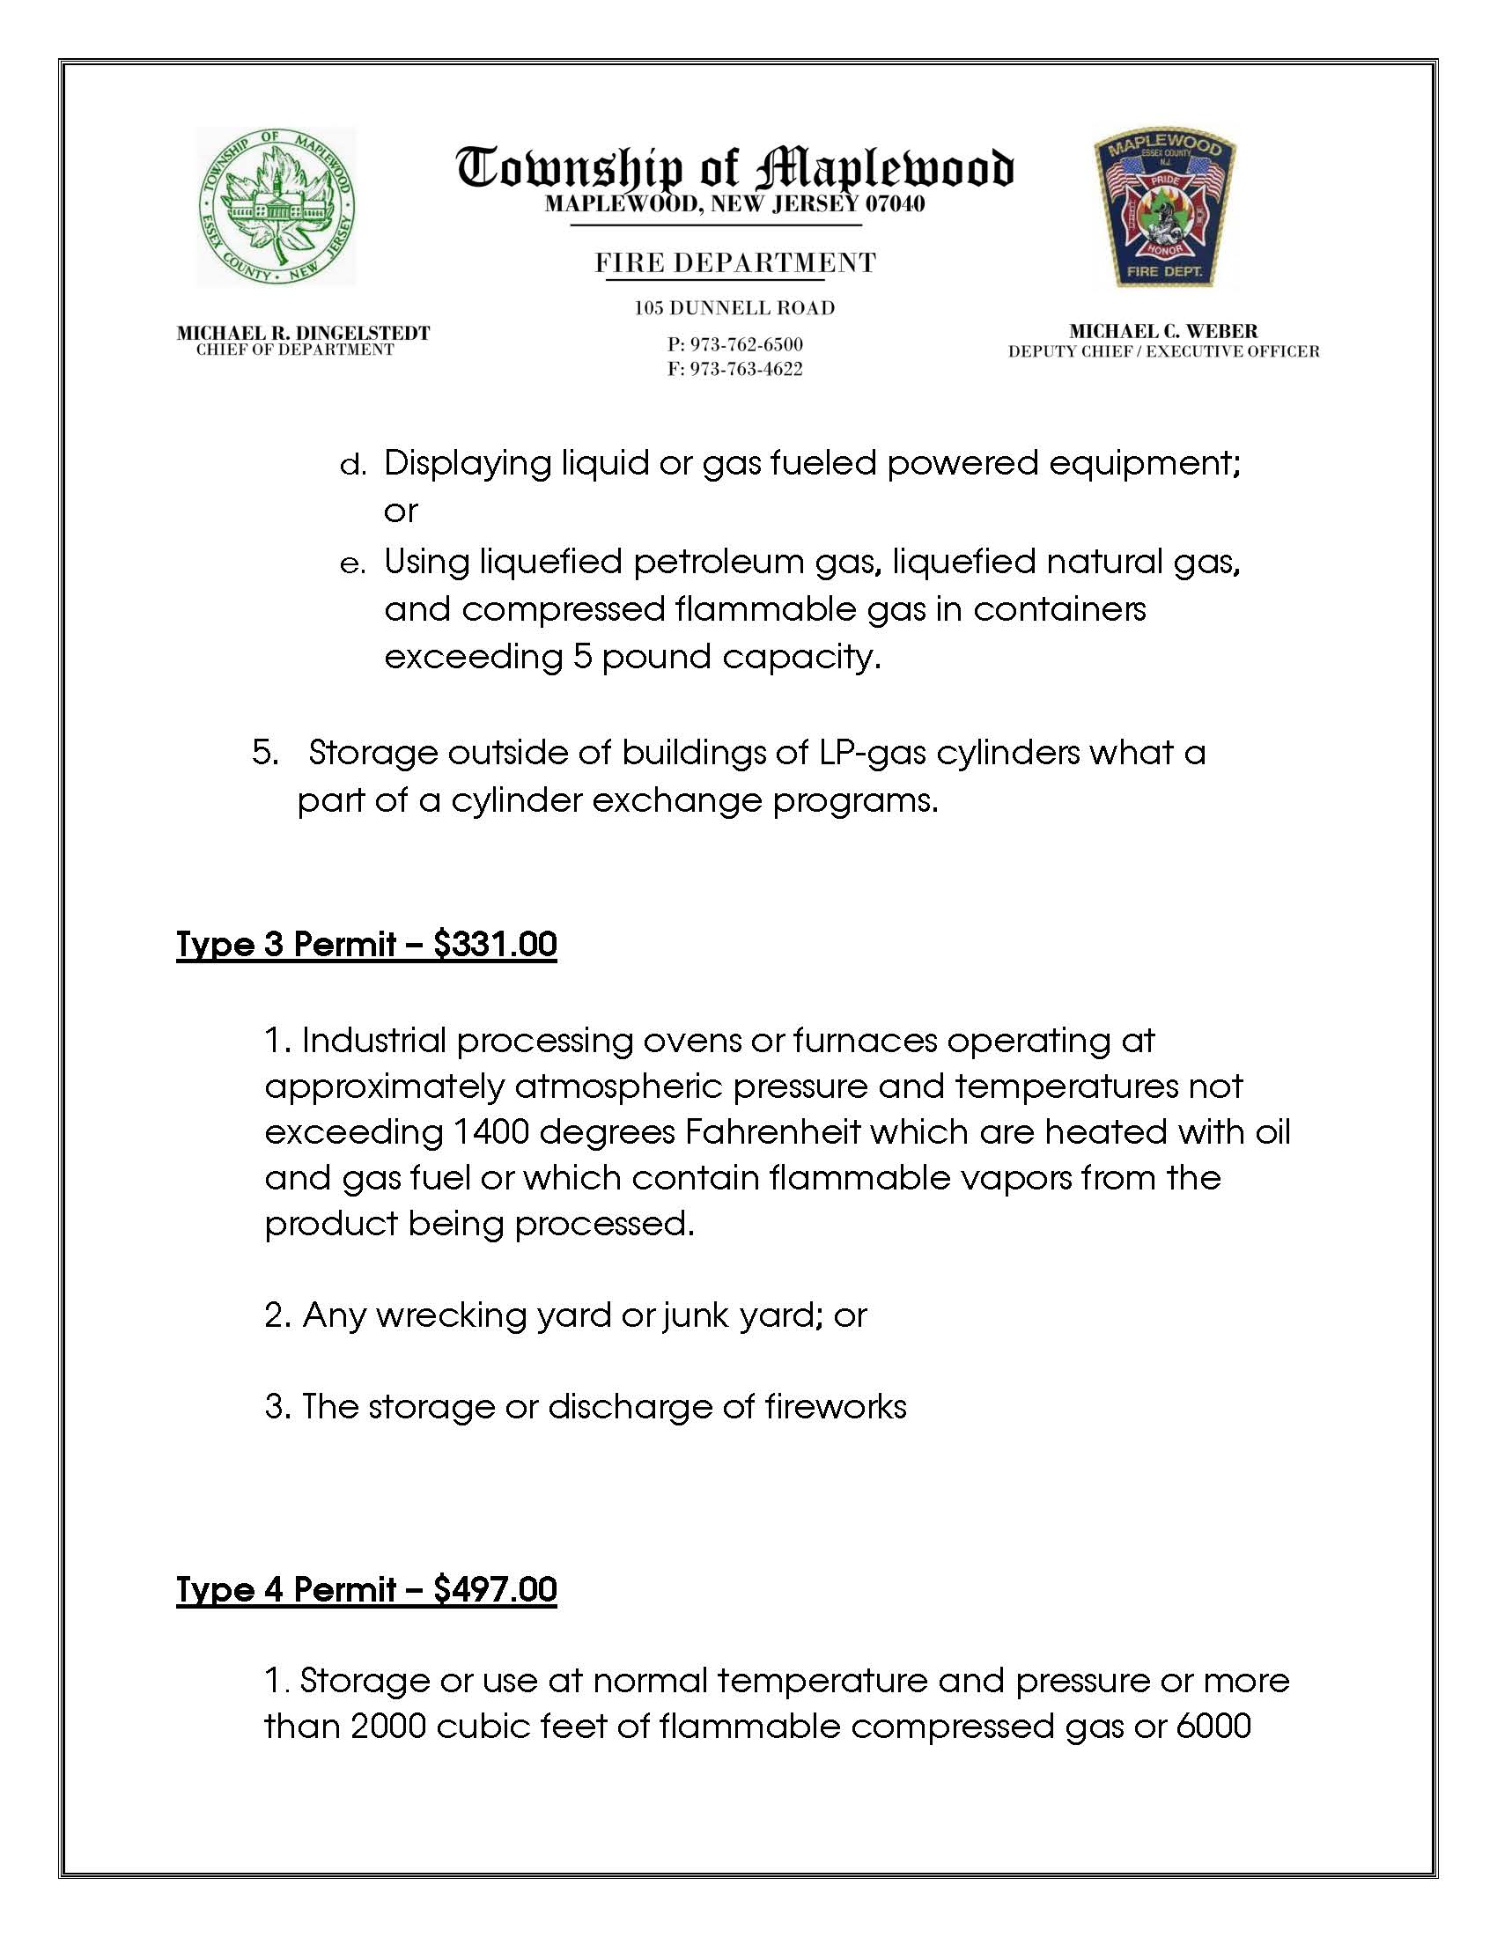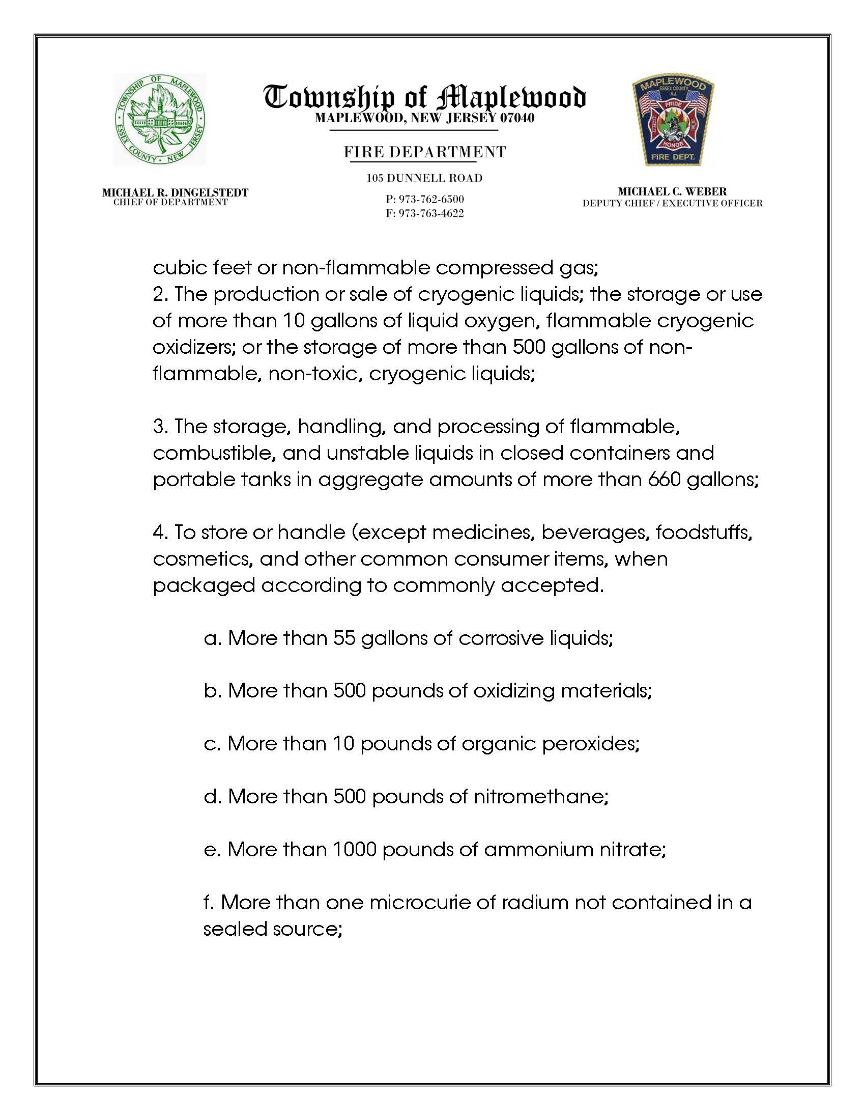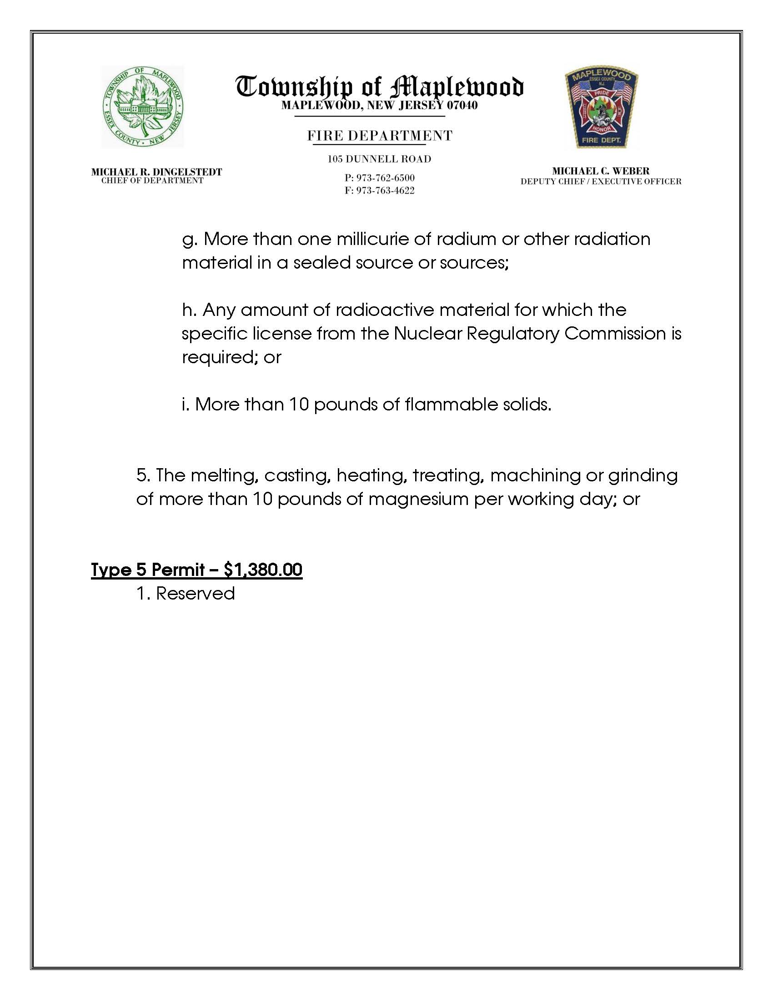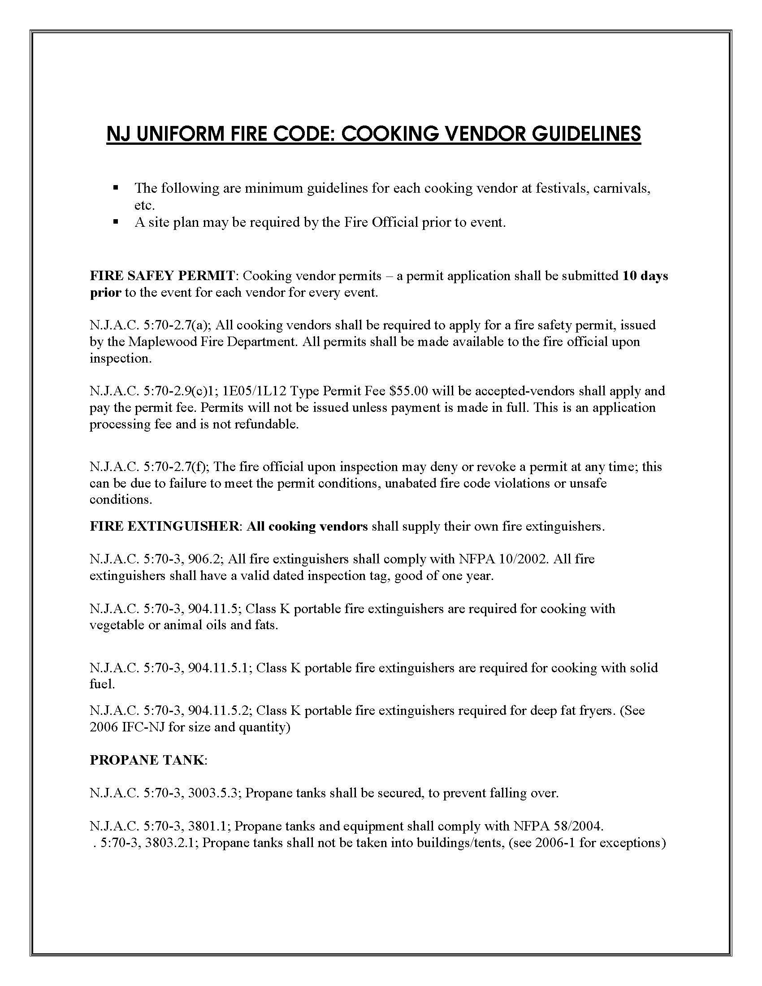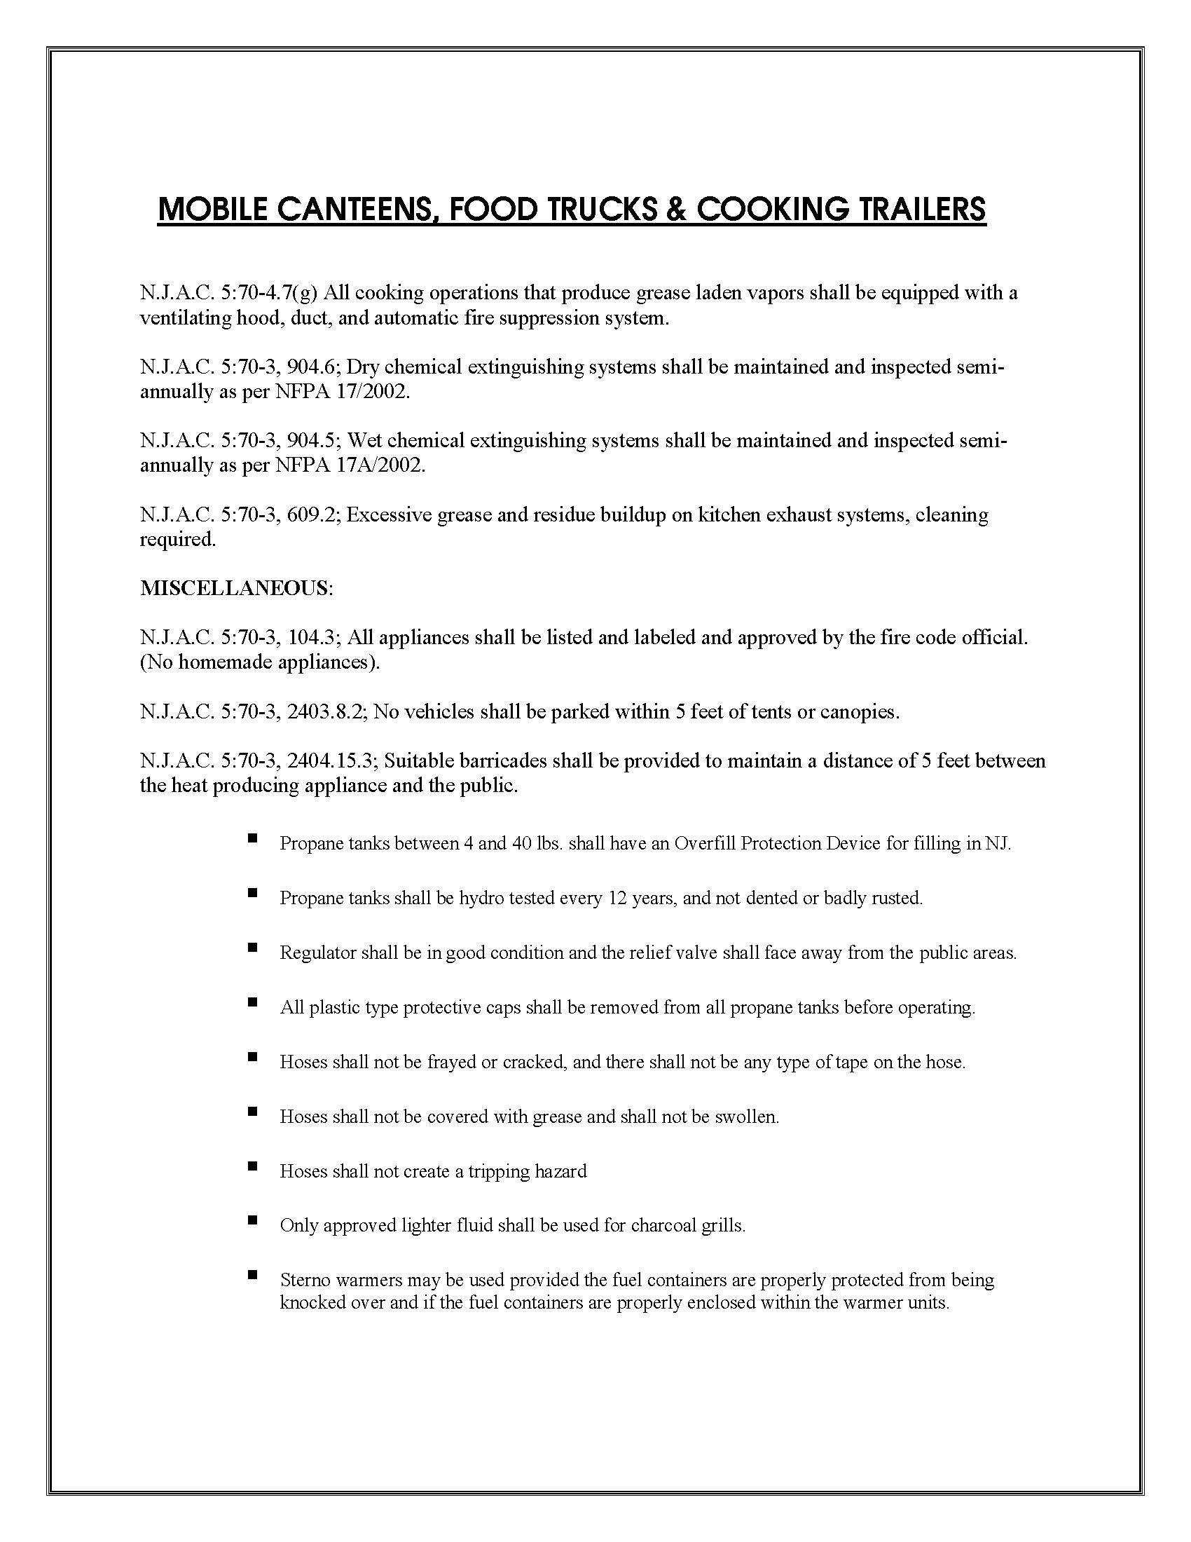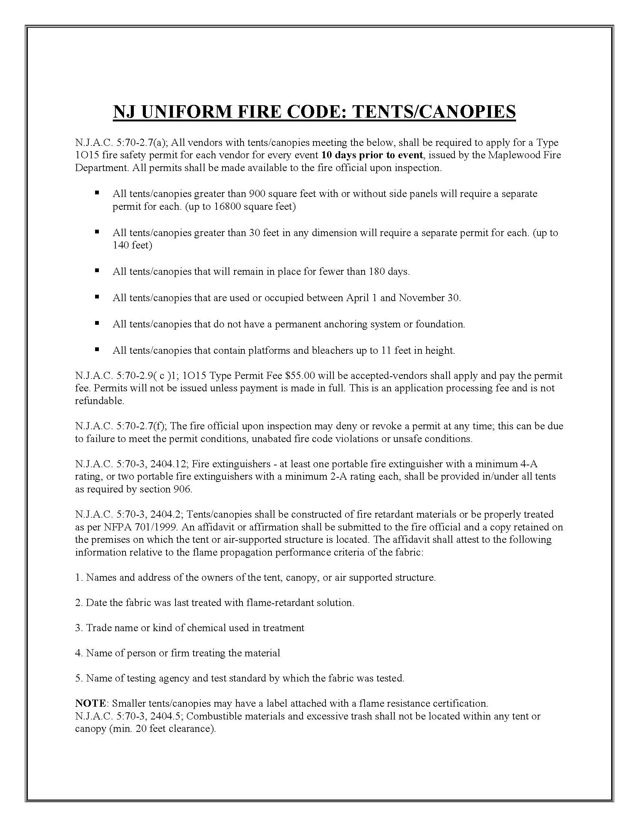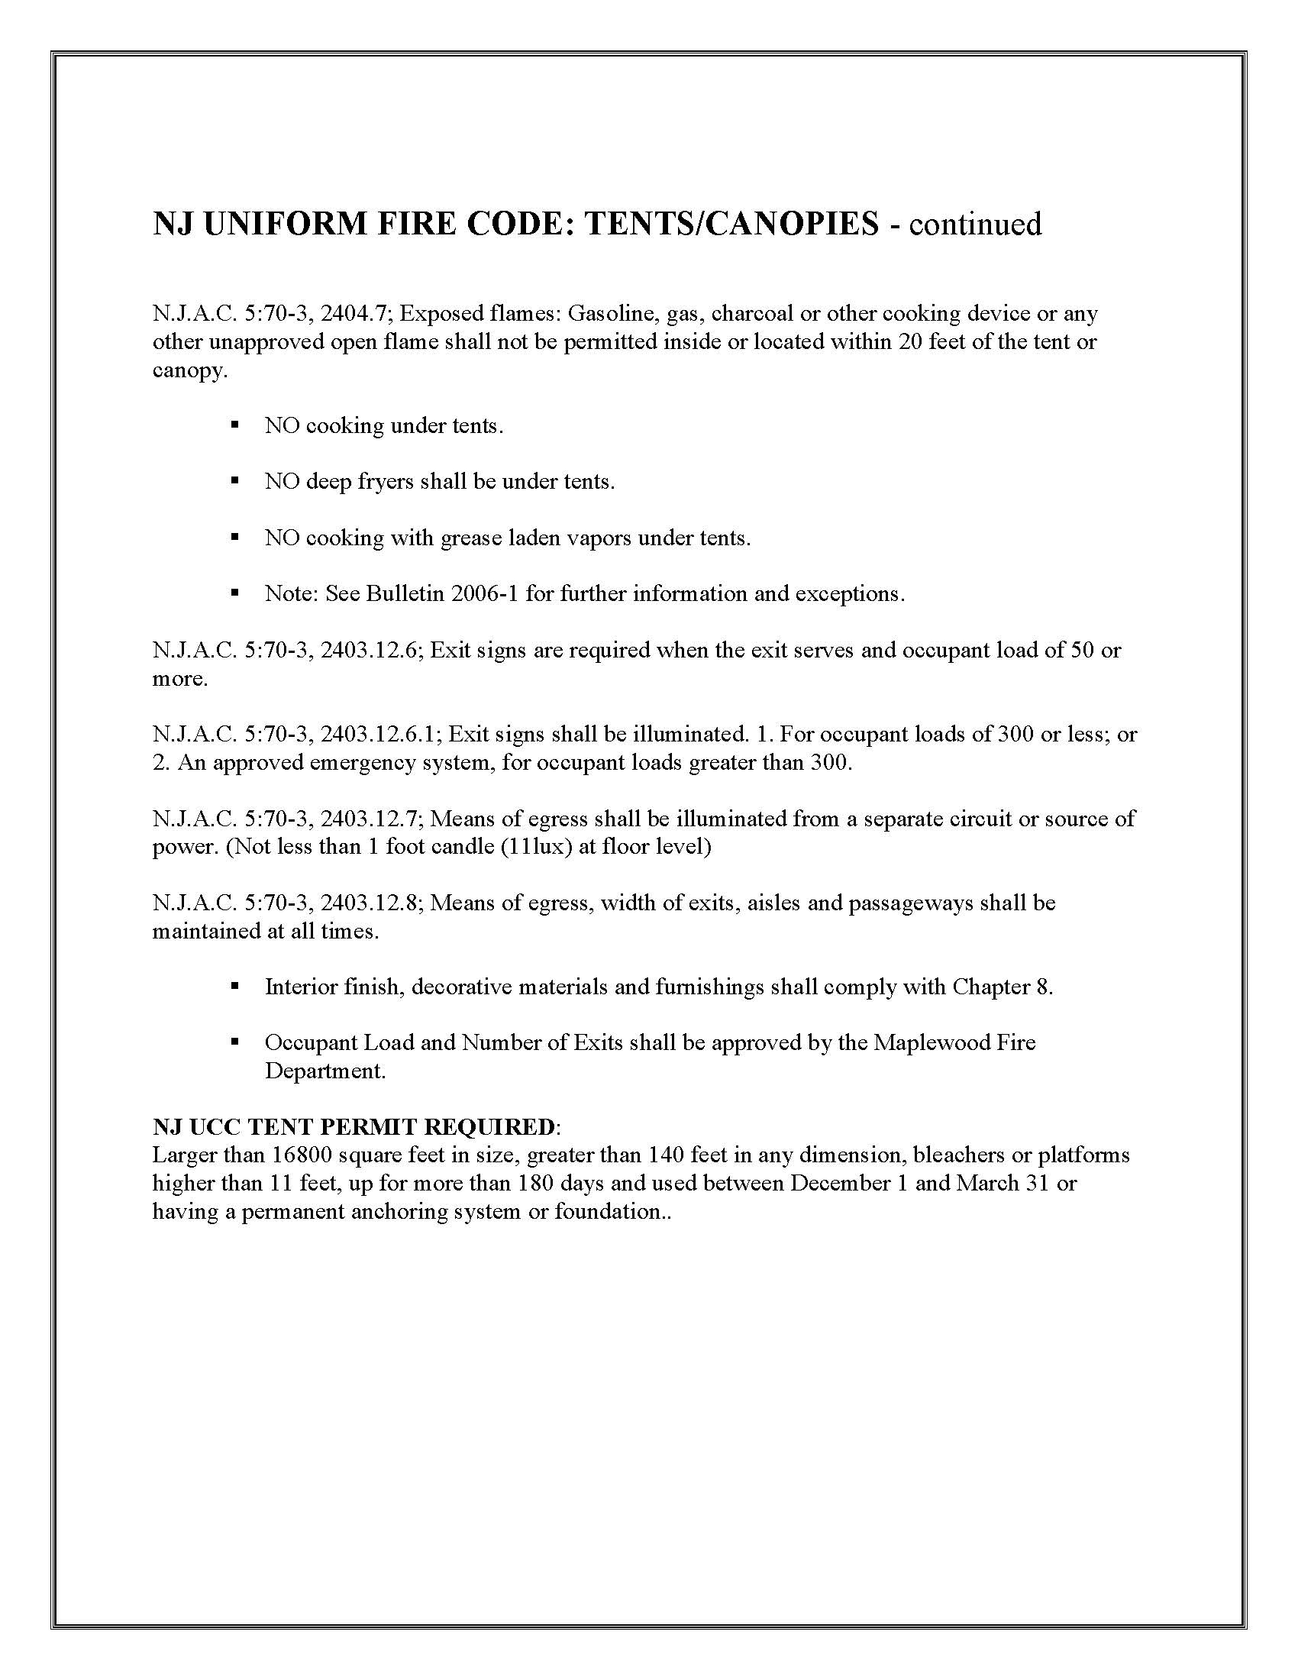
APPENDIX II

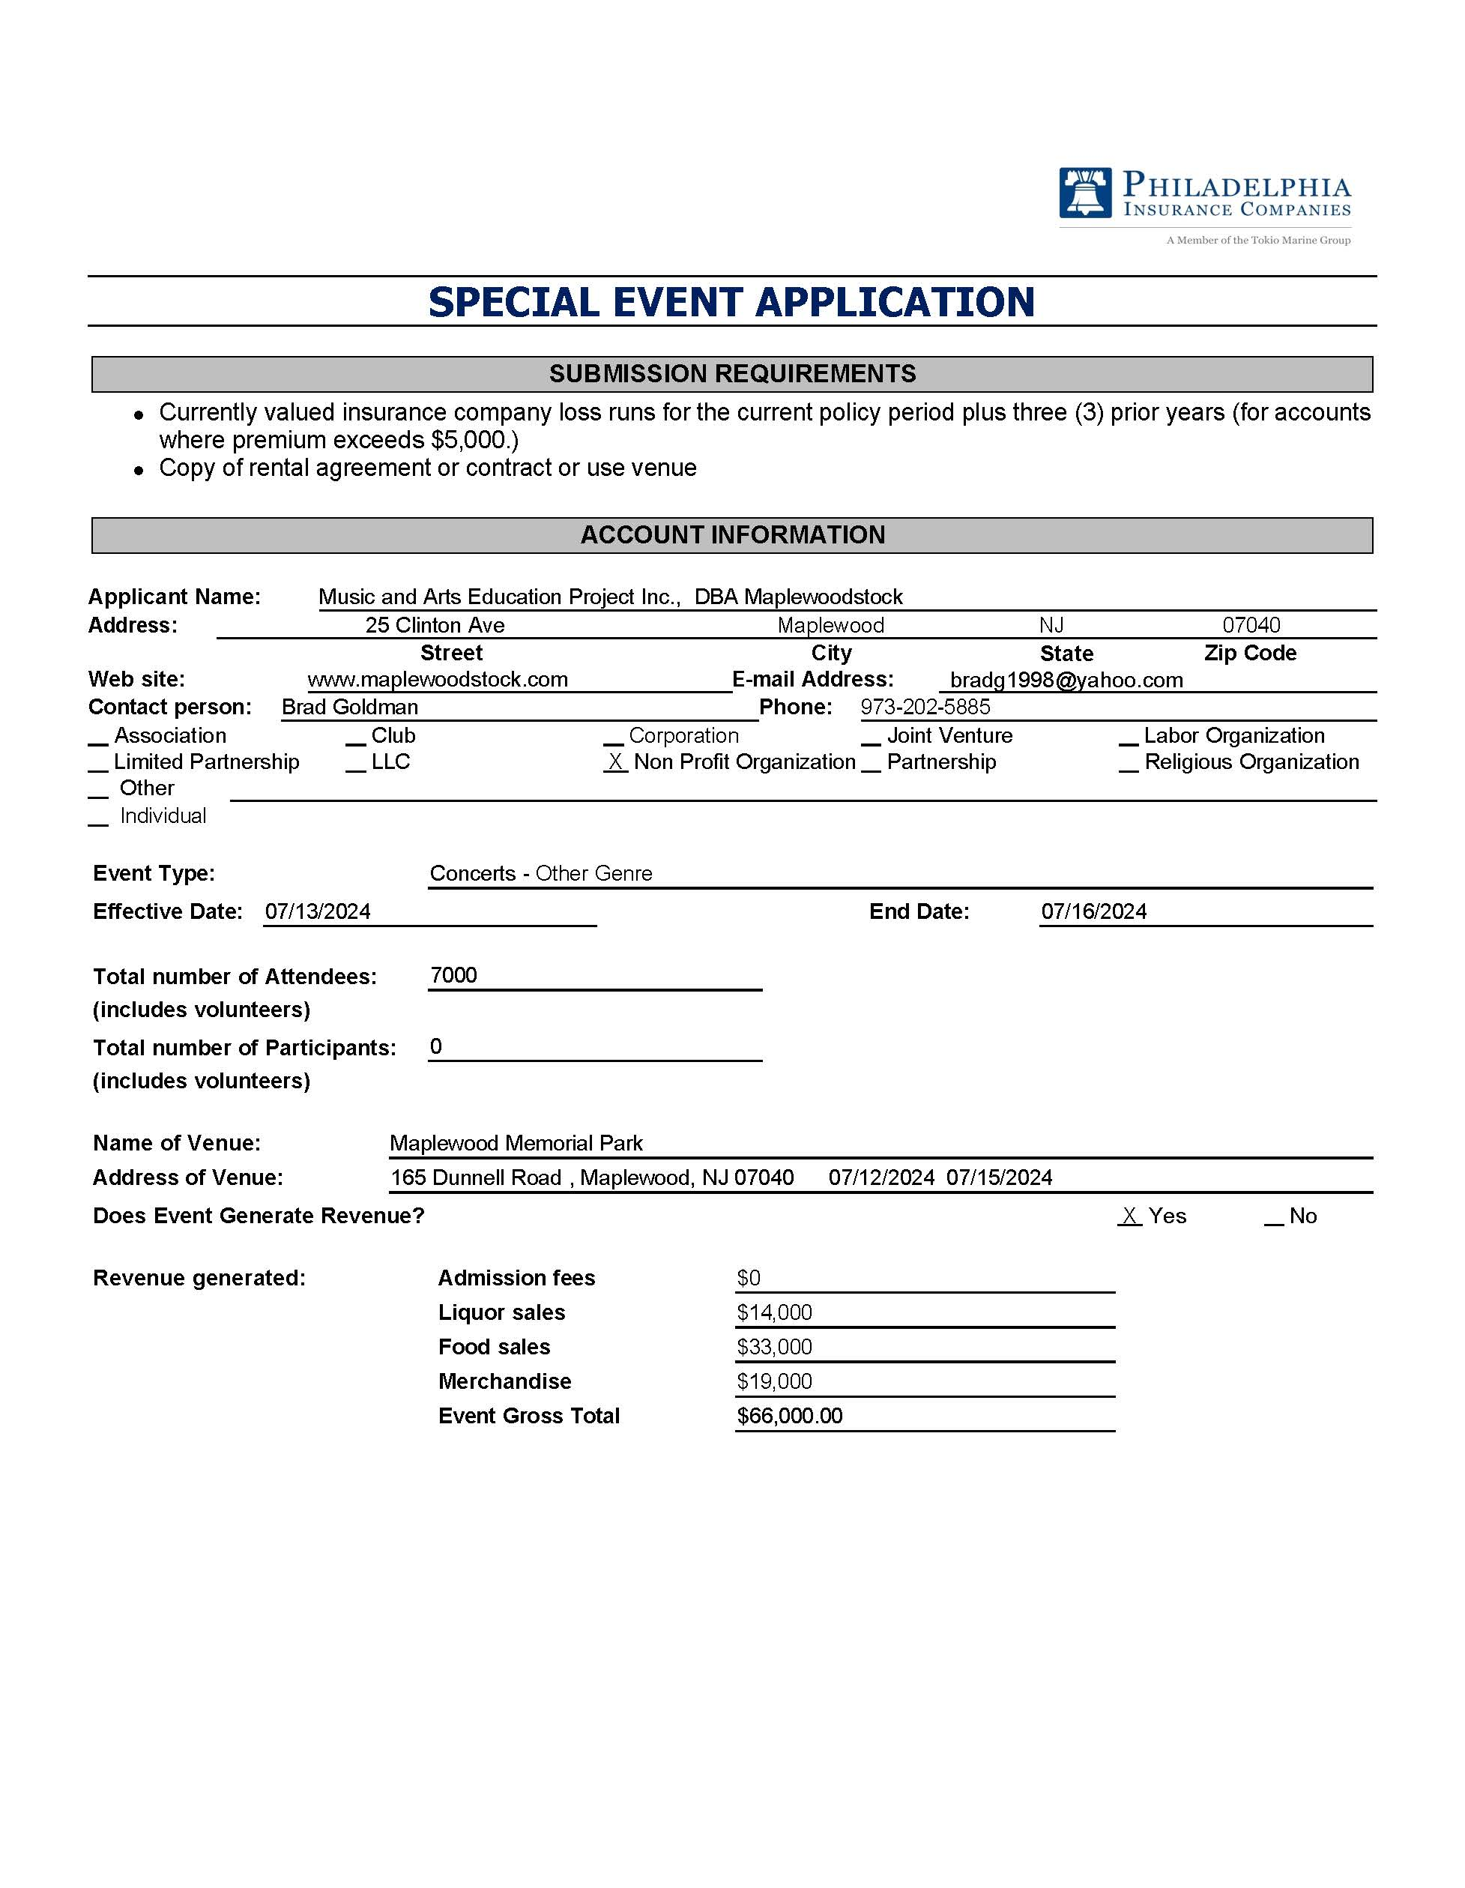
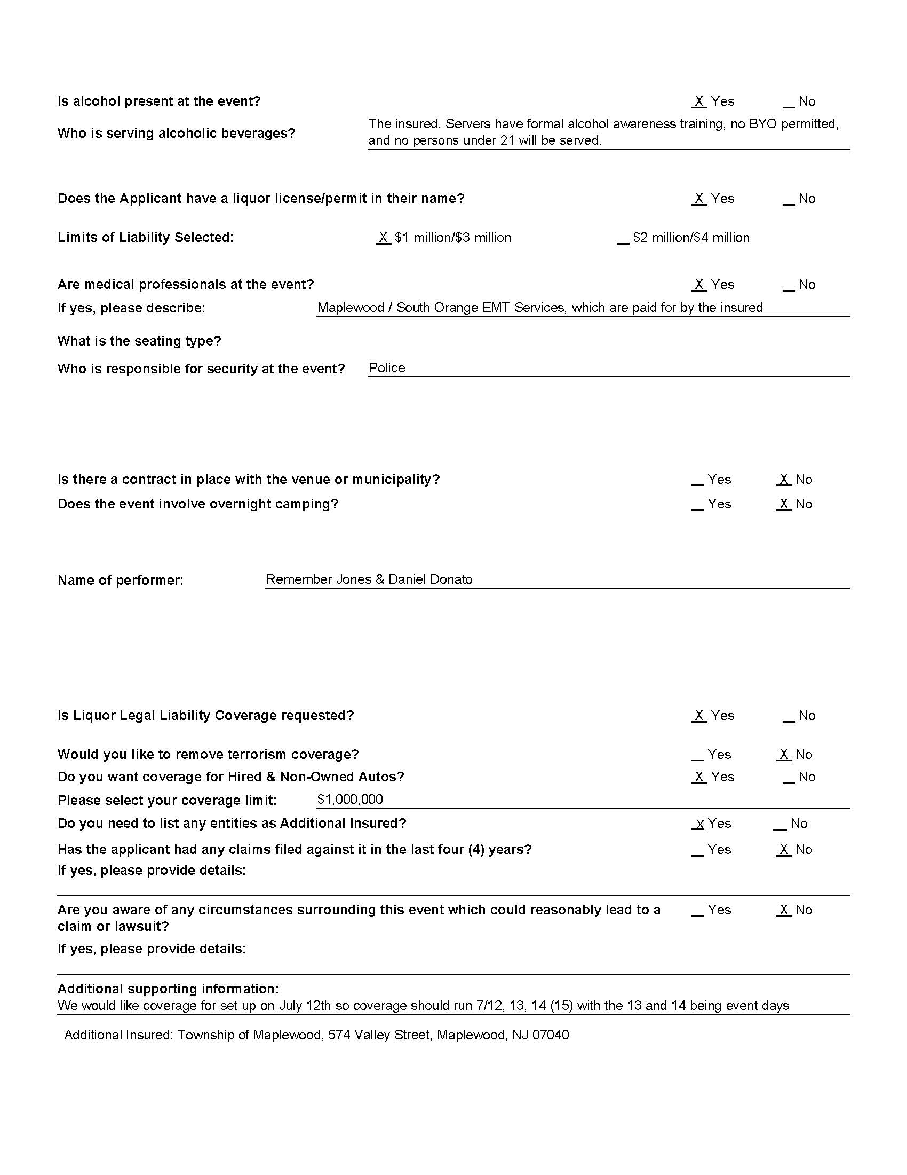
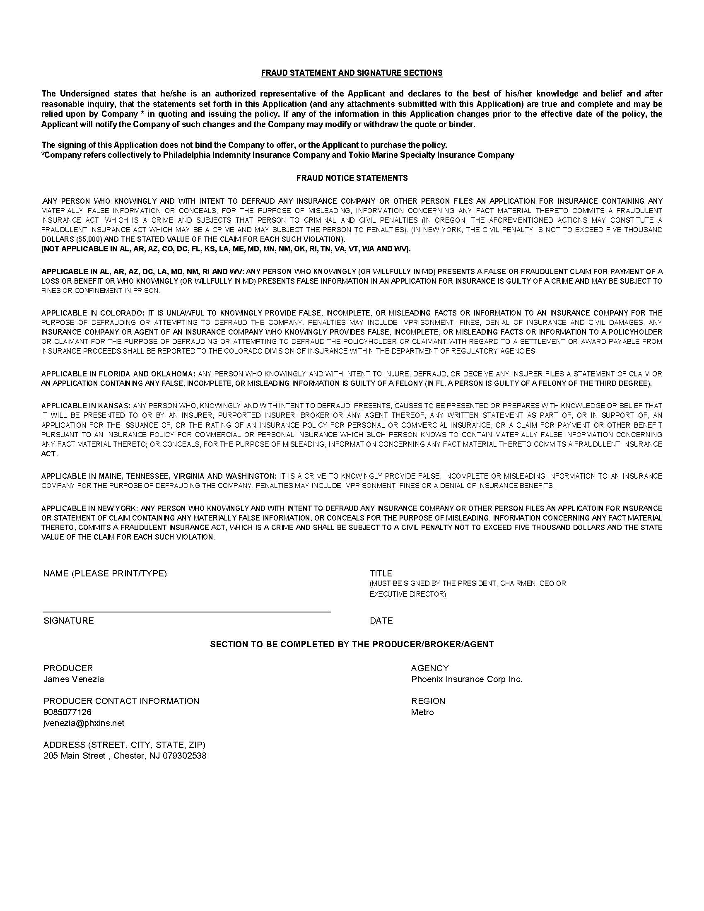

APPENDIX III

2024 MAPLEWOODSTOCK MUSIC AND ARTS FESTIVAL
AGENDA
Township Department Heads Meeting
May 20, 2024

- Introductions
- Administration
  - Event application submitted.
  - Social affairs permit received.
  - Insurance purchased. (COI submitted to township)
- DPW discussion
  - Dumpsters – same as last year.
  - Trash and recycling receptacles.
    - We’re selling water in cans this year so additional recycling may be necessary.
  - Light Towers
    - How many are available?
    - How do we go about requesting from the county?
  - Set-up
    - Stage to arrive sometime on Friday (TBD)
    - Stakes for walking lanes (with enough caution tape)
    - Snow fencing behind the stage.
    - Snow fencing for beer/wine garden.
- Police/Security discussion
  - Proposed security needs attached. – request quote.
  - Proposing that Oakview be One-way from west to east (Dunnell to Valley) (This is different than last year).
  - Dunnell closed to public traffic (except Handicap parking) from Oakview to Baker St.
  - Baker St. (from Valley to Dunnell) to be reserved for Vendor parking. – Further parking discussion at a future meeting. (Once vendor application process is completed)
  - Emergency egress lanes to be discussed at that future meeting.

- EMS/SO Rescue Squad
  - Request the same as last year – SORS rig and personnel on site.
- Food vendor permits, health requirements/etc
- Other items as required.

SOCIAL AFFAIRS PERMIT

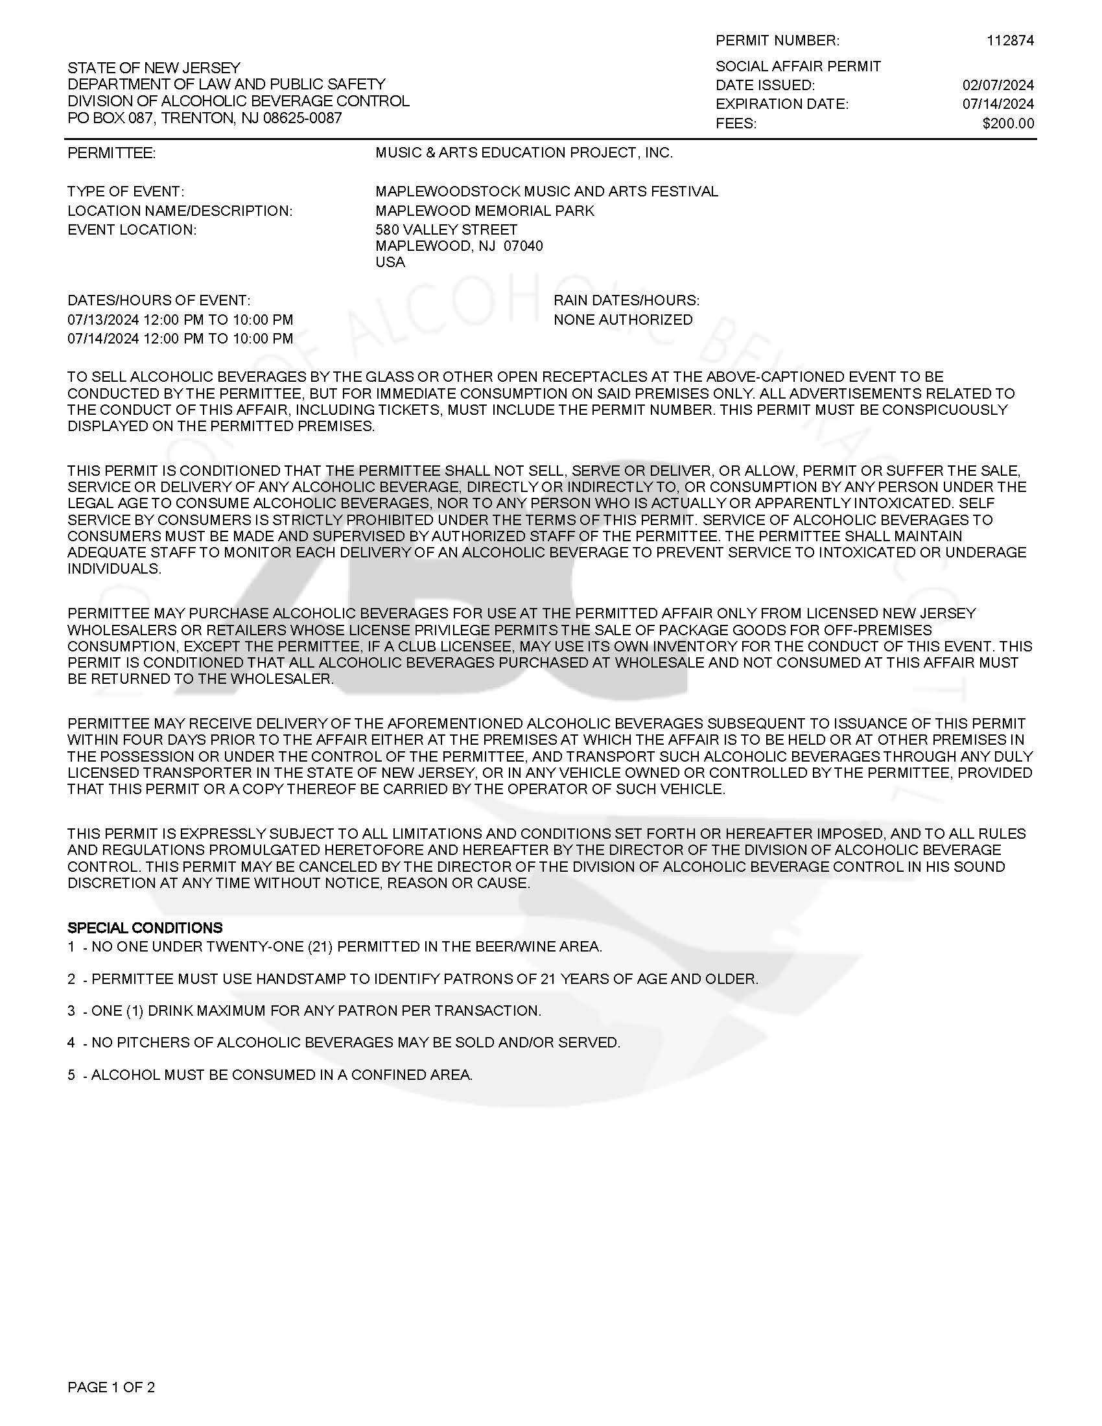

CERTIFICATE OF INSURANCE
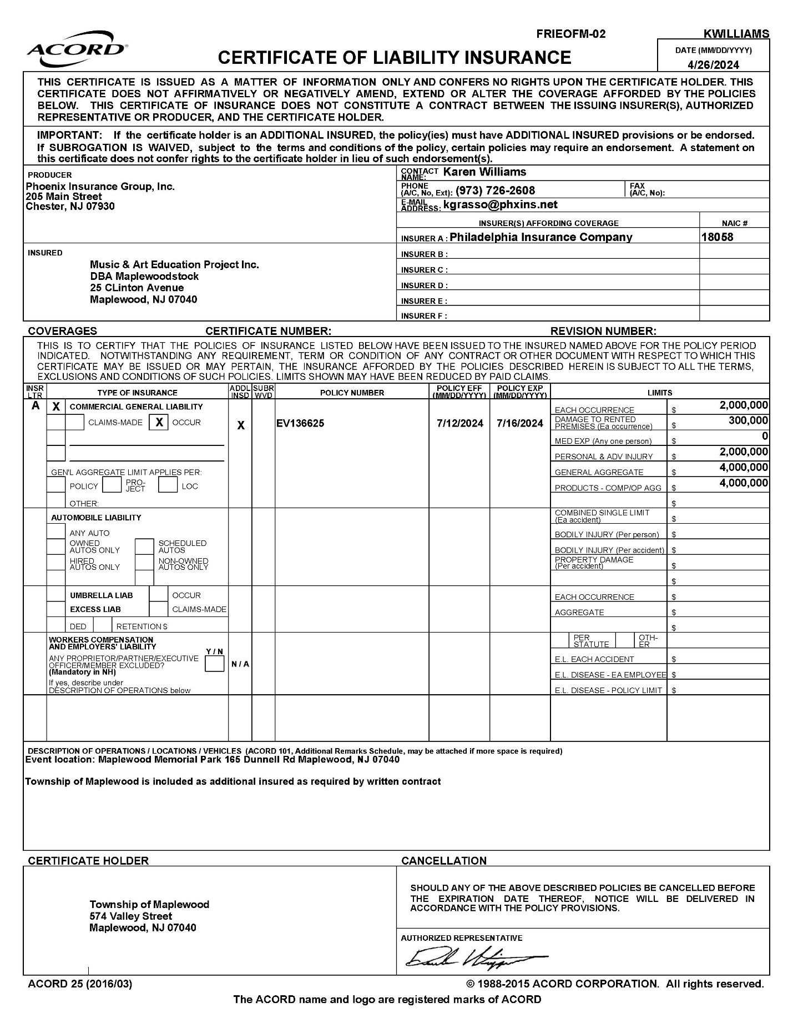

APPENDIX IV
SCHEDULE OF SECURITY NEEDS

Security needs for Maplewoodstock 2024

 | Saturday | Sunday
Traffic:  2 officers – 1 at Valley/Oakview & 1 at Dunnell/Oakview | 8:00am thru 11:00pm | 8:00am thru 11:00pm
Beer Garden:  1 Officer | 12:00pm thru 9:00pm | 12:00pm thru 9:00pm
Kid Zone:  1 Officer | 12:00pm thru 9:00pm | 12:00pm thru 9:00pm
Stage Security:  1 Officer | 4:00pm thru 10:00pm | 4:00pm thru 10:00pm
Event Security:  Shift 1  3 Officers (1 east field / 2 hill) | 2:00pm thru  5:00pm | 2:00pm thru  5:00pm
Event Security:  Shift 2  5 Officers (1 east field / 4 hill) | 5:00pm thru  11:00pm | 5:00pm thru 11:00pm

APPENDIX V
BAND LINEUP

Saturday | Start Time | End Time | Emails | Accepted
Sara Bernadette | 12:00 | 12:30 | sarahbernadettemusic@gmail.com
Daniel Feinberg | 12:45 | 1:15 | danielscottfeinberg@gmail.com
DC and the Desperados | 1:30 | 2:00 | peterevangin@gmail.com
Sheik’s Garage | 2:15 | 2:45 | markg923@yahoo.com
Dipsea Flower | 3:00 | 3:30 | marleystriemmusic@gmail.com
The Extensions | 3:45 | 4:15 | rebeccacristino@gmail.com
Deadtide | 4:30 | 5:00 | ksheldon123@gmail.com
Believe in Ghost! | 5:15 | 5:45 | believeinghostnyc@gmail.com
DJ Prince Hakim | 6:00 | 6:30 | Hakimbell@gmail.com
TRANSITION | 6:30 | 7:00
Nation Beat | 7:00 | 8:00
TRANSITION | 8:00 | 8:30
Remember Jones | 8:30 | 10:00

Sunday | Start Time | End Time | Emails | Accepted
Sasso | 12:00 | 12:30 | shaneanstendig@icloud.com
Joy and the Wildfire | 12:45 | 1:15 | samantha@samanthajoypearlman.com
Emily Cavanagh | 1:30 | 2:00 | emilycavanaghmusic@gmail.com
Gina D’Soto | 2:15 | 2:45 | ginaofficial97@gmail.com
Skyfactor | 3:00 | 3:30 | Rnziegler@gmail.com
Owls and Lions | 3:45 | 4:15 | jay@spinnersent.com
Honest Wagner | 4:30 | 5:00 | brookswould@gmail.com
The Parkers | 5:15 | 5:45 | anya.parkerlentz@gmail.com
Alessandra & the Smallworld Band | 6:00 | 6:30 | smallworldmusik@gmail.com
Tia Holt Experience | 6:45 | 7:30 | Thetiaholtexperience@gmail.com
TRANSITION | 7:30 | 8:00
Daniel Donato | 8:00 | 9:30

APPENDIX VI

EXAMPLES OF EMAILS TO BANDS

EXAMPLE OF AN EMAIL TO A SELECTED BAND

Hello from Maplewoodstock:

Congratulations! We are happy to extend an invitation to sasso to perform at Maplewoodstock 2024, which takes place on Saturday, July 13th and Sunday, July 14th. Your performance slot (subject to change) is:
Saturday, July 13th at 12:00 pm.
We will be holding a mandatory all-bands meeting locally (Maplewood vicinity) sometime in June (Date TBD). You will be required to have a representative at this meeting. We will notify you shortly with more details about that meeting including how to participate remotely.
Here is a quick overview:
- We supply a professional stage and sound company.
- You’ll need to submit a stage diagram that shows instruments and vocals (Stage Plot).
- We supply the backline including drums. Drummers are welcome to bring their own cymbals (a full backline listing will be distributed at the all-bands meeting).
- You will have 30 minute set.
- You need to arrive backstage 45 minutes before your start time.
- We will provide a $150 honorarium before your set
Thank you for participating in the band application process for Maplewoodstock 2024.
Please confirm by end of day Friday, April 12th, to this email address (kernst@comcast.net) if you accept our offer to perform.

Thank you,
Maplewoodstock 2024 Music Committee

EMAIL TO WAITLISTED BANDS

Hello from Maplewoodstock:
As always, we are so grateful for such an overwhelming response to the Maplewoodstock submission process. We had a record number of submissions (over 120) and, once again, a record number or first timers. This process is always a difficult one, and each year the number of qualified submission increases.

Although you did not make the primary list we would like to hold you and a very small select group on our wait list. In previous years we have had multiple bands move up from the wait list. We considered a number of factors, so please do not take this as any reflection of your band’s talent.

There have been cases when a band has had to cancel right before the event, however we will do our best to inform you as soon as we can if there is an opportunity for your band to be added to the line-up.

Thank you, and we would welcome your application next year, as one of our goals is to rotate the performers.

Sincerely,

Maplewoodstock Music Committee 2024

EMAIL TO BANDS NOT SELECTED

Hello from Maplewoodstock:
As always, we are so grateful for such an overwhelming response to the Maplewoodstock submission process. We had a record number of submissions (over 120 of which we can only select 19) and, once again, a record number or first timers. This process is always a difficult one, and each year the number of qualified submission increases.

We appreciate your application. Unfortunately we will not be able to include you in this year’s lineup. We considered a number of factors - this is not a reflection of your band’s talent.

Thank you again, and we would welcome your application next year, as one of our goals is to rotate the performers.

Sincerely,

Maplewoodstock Music Committee 2024

APPENDIX VII

AGENDA & ATTACHMENTS FOR BAND MEETING

Greetings to you, the 2024 Maplewoodstock performers!!

I hope you are all enjoying the spring.

As I mentioned in the past we have a "Band Meeting" prior to the event to go over logistics and to address any questions you may have. This year's meeting is to take place on the evening of June 13th at 7:00pm. We ask that at least one representative from your band attend. The location is the Memorial Park Civic House at 124 Dunnell Rd, Maplewood, NJ. Historically this meeting was in-person, and we will do so again this year. It's always a fun meeting an we enjoy meeting all of you prior to the event. However, since we've become so proficient with remote meetings we will offer a remote alternative as well for those who can not attend in person. I will send a remote invite as the date gets closer.

We would like to get a head start with our preparation. We require all bands to send us a stage plot (and example is included in the attached package). Please send your stage plot to this email address (kernst@comcast.net) soon as you can, but no later than June 13th.

I have attached two documents. One is the meeting package that includes the agenda, and the band lineup, a stage plot example, and a very crude driving map, (backline to be sent in the near future). The other is your Vehicle Access Pass which allows you to drive onto Oakview Ave and then park on Dunnell Road. YOU MUST HAVE THIS PASS TO GAIN ENTRANCE.

Also, once again we will have a sign language interpreter on stage for every act. We will be asking for your set lists and song lyrics prior to the event. We understand that set lists are sometimes not finalized far in advance, but as soon as they are finalized please send them to this email address as soon as you can. If not, I promise to continue to hound you until you provide them. 😣

Please indicated whether you or your representative will attend in person or remotely by replying to this email address.

Best
Tom Kerns
Chair, Maplewoodstock Volunteer Committee

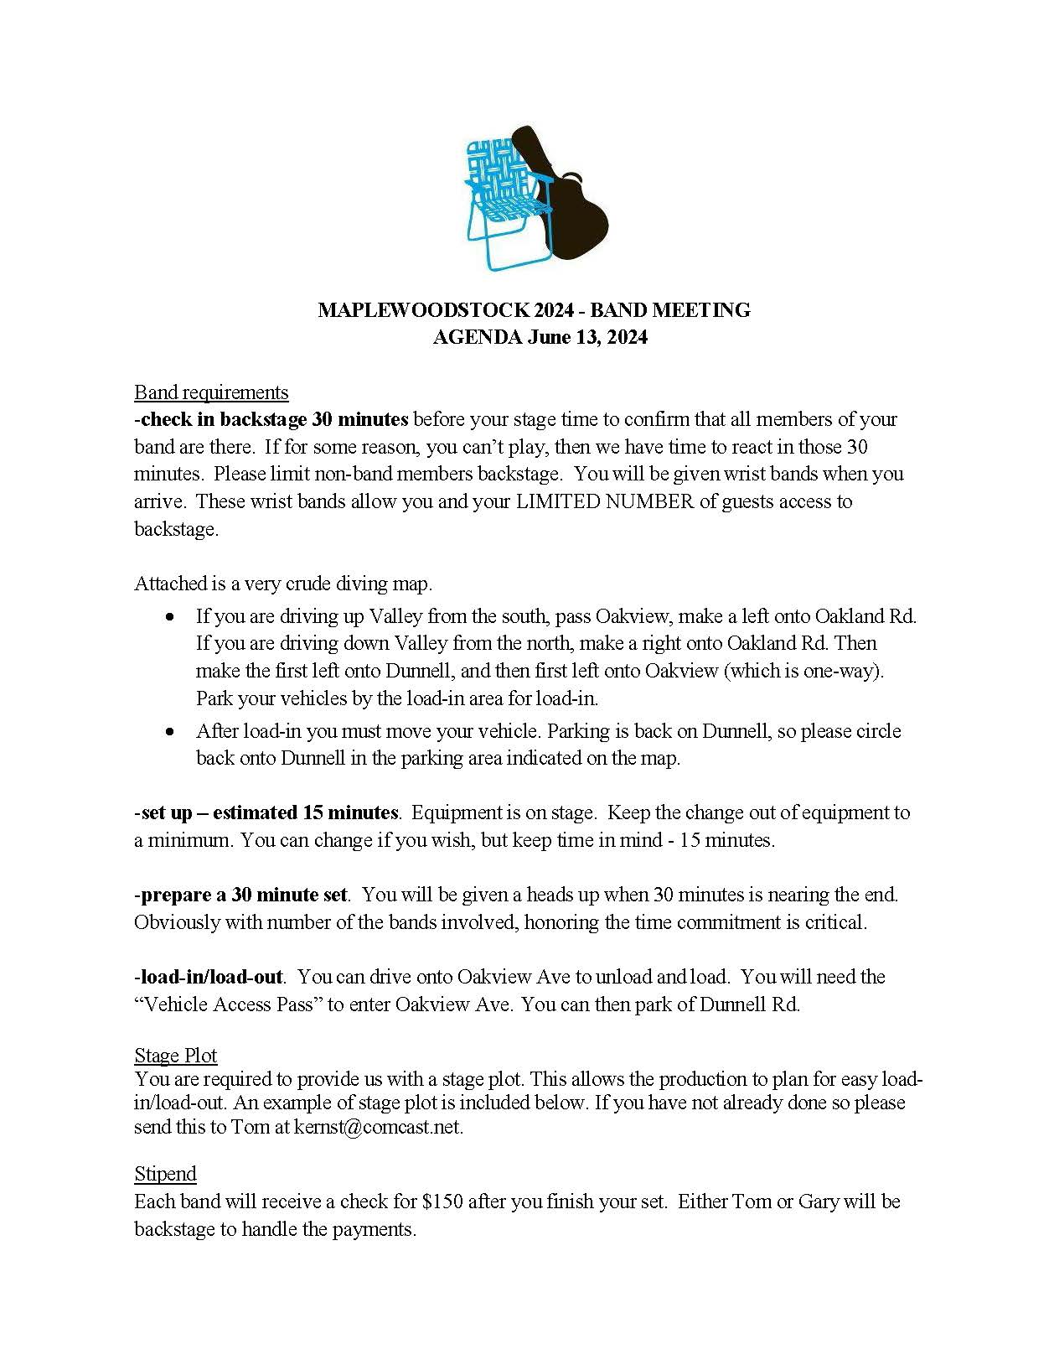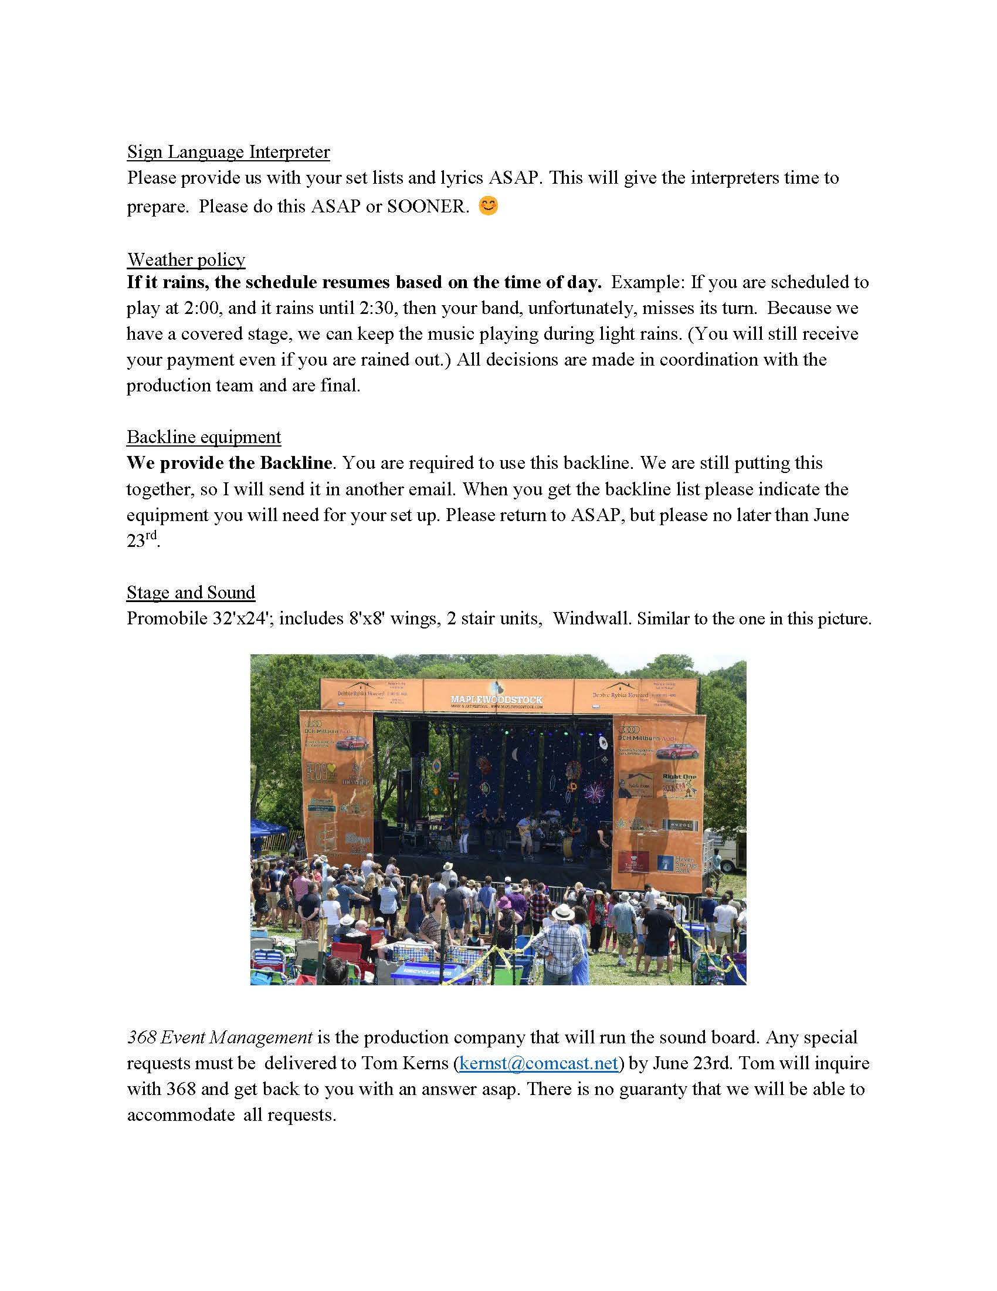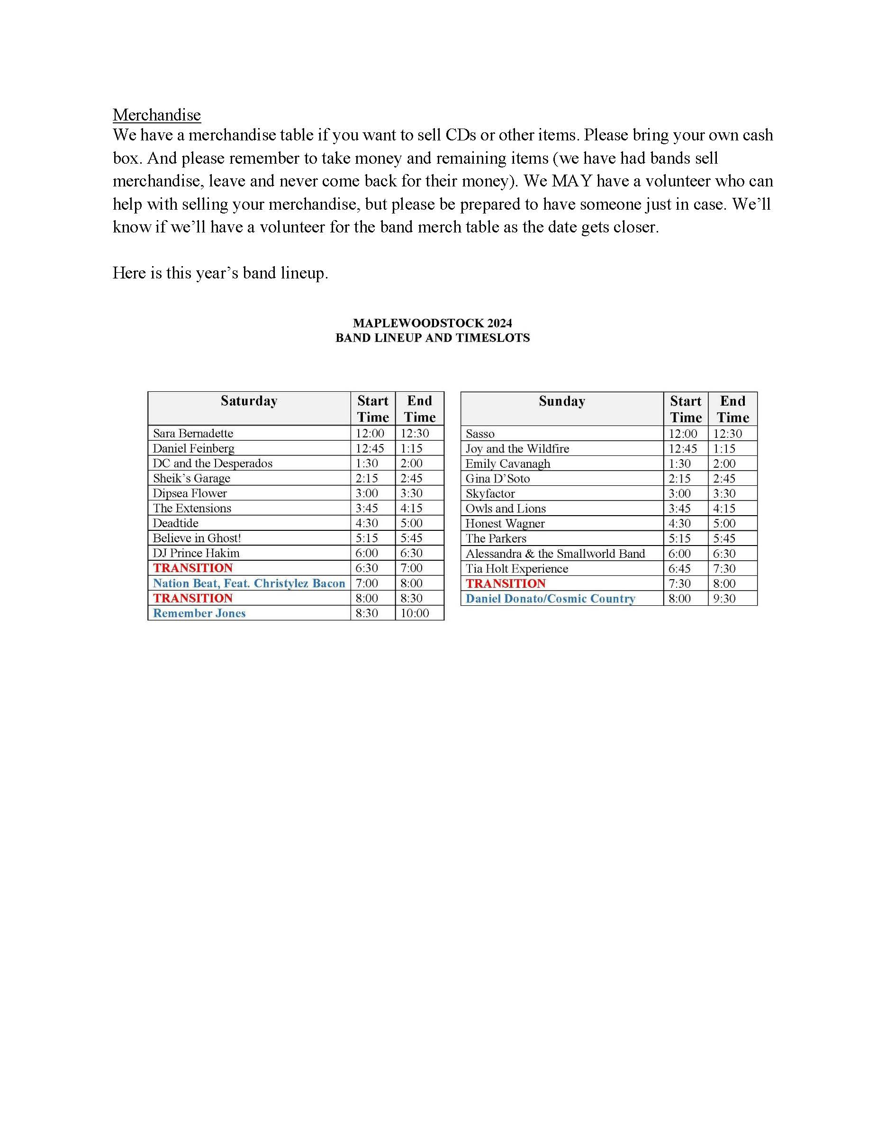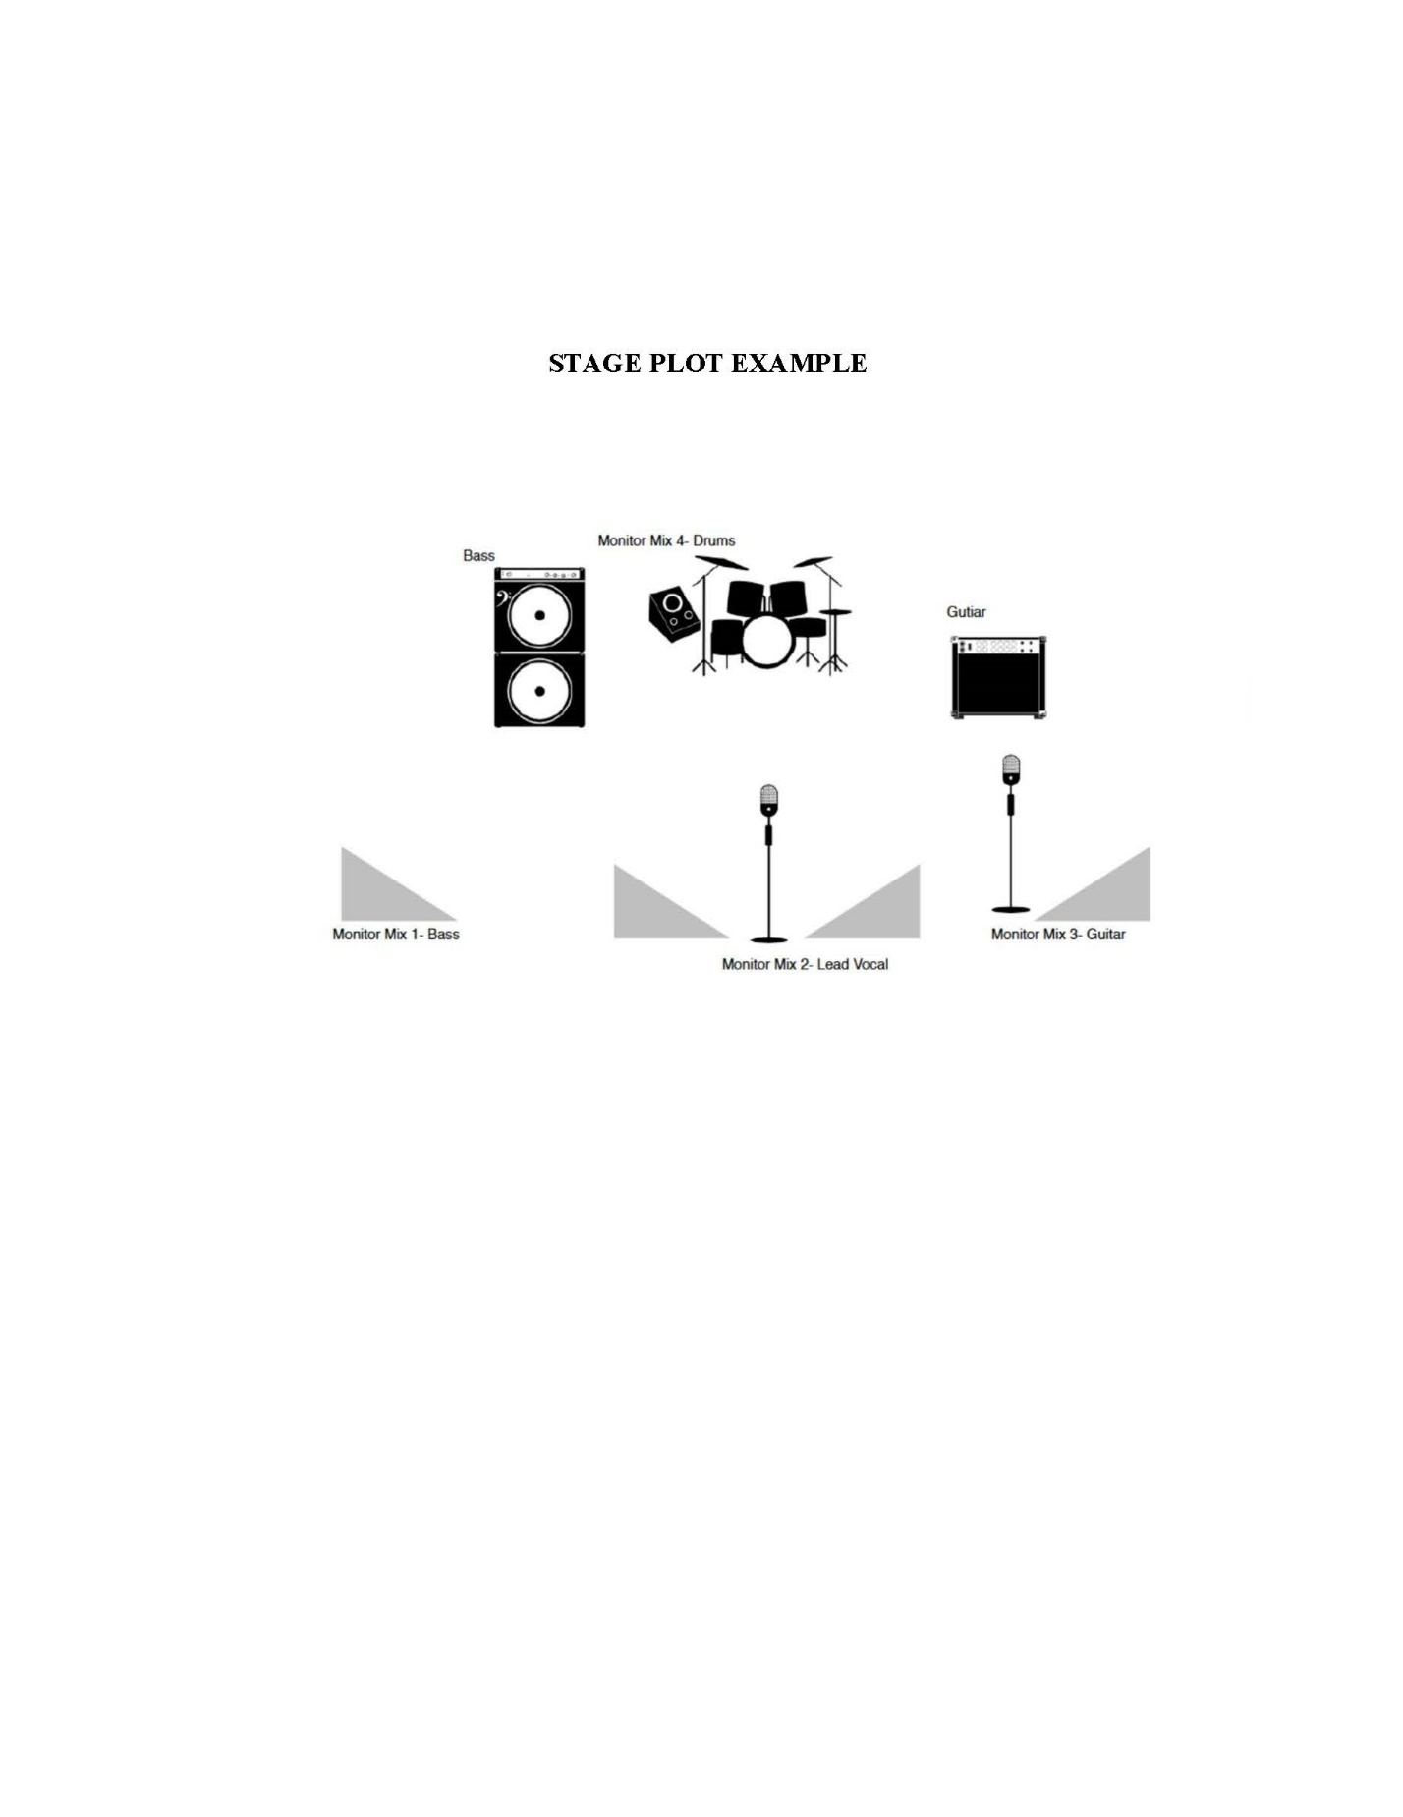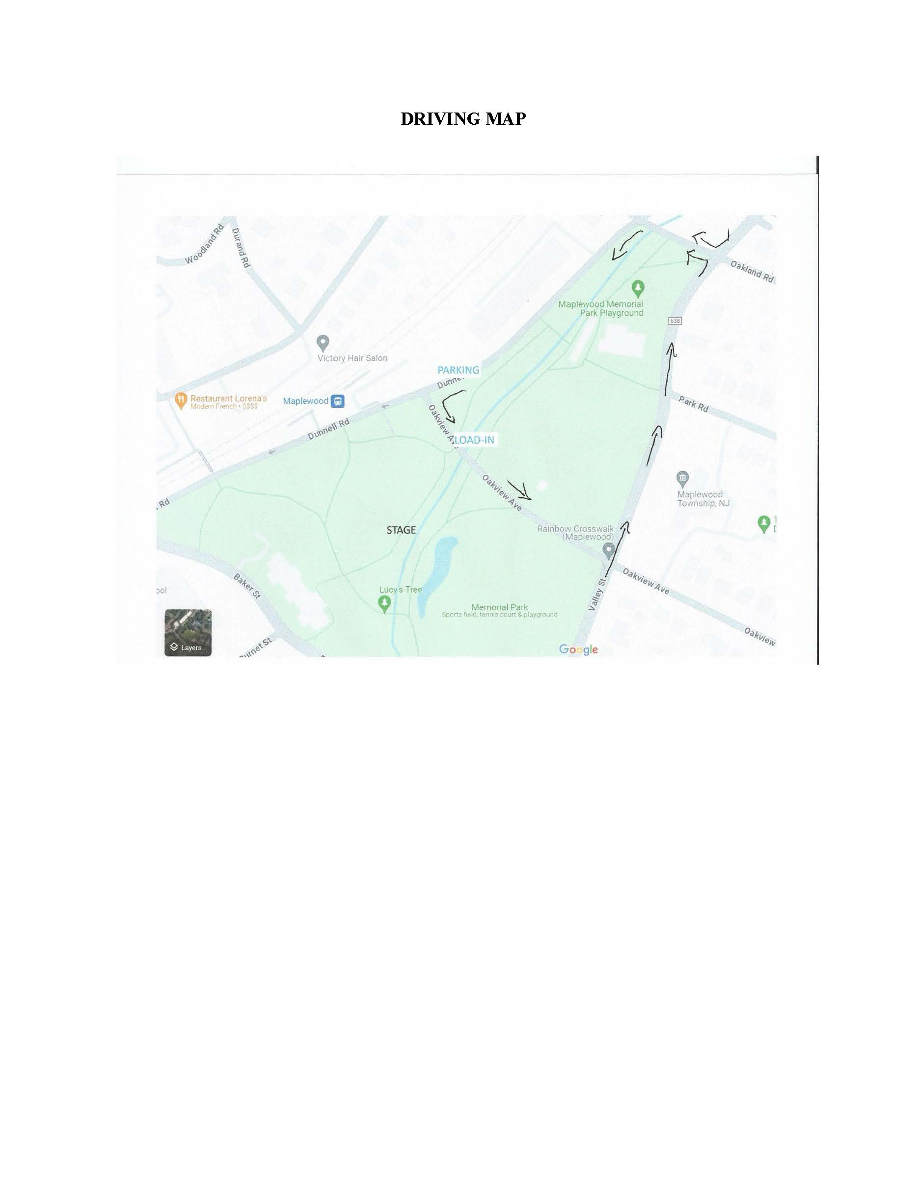

Maplewoodstock Backline 2024
Item | Qty
DRUMS
Drum Rug | 1
Pearl 22"x16" Masters Studio Bass Drum, no tom mount | 1
Pearl 16"x16" Masters Studio Floor Tom w/ legs | 1
Pearl 10"x8" Masters Studio Rack Tom | 1
Pearl 14"x6.5" Master Studio Birch Snare | 1
Pearl Round Drum Throne | 1
Pearl Boom Cymbal Stand | 3
Pearl Snare Stand | 1
Pearl Hi Hat Stand, Eliminator | 1
Zildjian 14" New Beats Hi Hats | 1
Zildjian 16" A Medium Crash | 1
Zildjian 18" A Medium Crash | 1
Zildjian 20" A Medium Ride | 1
GUITAR
Marshall JCM 900 | 1
Marshall 1960 4x12 Slant Speaker Cabinet | 1
Fender Hot Rod Deville 2x12 Combo | 1
BASS
Ampeg SVT Bass Head | 2
Ampeg 4x10 Cabinet | 2

APPENDIX VIII

BAND INTRODUCTION SCHEDULE / ANNOUNCEMENTS

Saturday | Start Time | End Time | MC | NOTES
Sara Bernadette | 12:00 | 12:30 | Jamie
Daniel Feinberg | 12:45 | 1:15 | Tom | Visit the vendors
DC and the Desperados | 1:30 | 2:00 | Tom
Sheik’s Garage | 2:15 | 2:45 | Jamie | Reminder to take everything with you when you leave incl trash
Dipsea Flower | 3:00 | 3:30 | Frank McGehee
Deadtide | 3:45 | 4:15 | Gary & sponsor | Sensory zone reminder
Believe in Ghost! | 4:30 | 5:00 | Gary & sponsor | Shout out to Volunteer groups
DJ Prince Hakim | 5:15 | 5:45 | Kevin | Shout out to SLIs
Troubleman | 6:00 | 6:30 | Kevin | Reminder to take everything with you when you leave, incl trash
TRANSITION | 6:30 | 7:00 | Tarquin | “ Short break” - “visit our vendors & beer Garden”, etc
Nation Beat | 7:00 | 8:00 | Tarquin
TRANSITION | 8:00 | 8:30
Remember Jones | 8:30 | 10:00 | Tom

Sunday | Start Time | End Time | MC | NOTES
Sasso | 12:00 | 12:30 | Jamie
Joy and the Wildfire | 12:45 | 1:15 | Jamie | Visit the vendors
Emily Cavanagh | 1:30 | 2:00 | Tom
Sarah Hodd & the Drive | 2:15 | 2:45 | Tom
Skyfactor | 3:00 | 3:30 | Jamie | Reminder to take everything with you when you leave incl trash
Owls and Lions | 3:45 | 4:15 | Tom | Sensory zone reminder; “visit our vendors, etc”
Honest Wagner | 4:30 | 5:00 | Gary & sponsor | Shout out to Volunteer groups
The Parkers | 5:15 | 5:45 | Kevin | Shout out to SLIs - need list of interpreters from Laurellie
Alessandra & the Smallworld Band | 6:00 | 6:30 | Kevin | Reminder to take everything with you when you leave incl trash
Tia Holt Experience | 6:45 | 7:30 | Kevin | Thanks for volunteers and those who donated $ or things
TRANSITION | 7:30 | 8:00 |  | Committee Thank You
Daniel Donato | 8:00 | 9:30 | Tarquin

APPENDIX IX

THANK YOU EMAIL TO TOWSHIP

Good morning, All

Another Maplewoodstock is behind us, and despite the slight interruption due to the rain on Sunday (for about an hour), based on the feedback we received it was a huge success!! Many of the vendors and bands have told us that most of the process was seamless and (almost) painless (there are always going to be those few....😉). That does not happen without the amazing cooperation from all of the township areas who are involved from the planning, application processes, permits, execution during the weekend, and all the way to Monday morning cleanup. From all of the members, and extended members, of the Maplewoodstock Volunteer Committee we send a huge thank you!! Here are some of our very positive impressions:

- As always, the Township Committee was very supportive of our efforts and are there to answer some pretty heady questions for us. So, Thank you Mayor Adams, Vice Mayor Cripe and the entire Township Committee.
- The planning process does not go smoothly without the help from the many township departments, starting with Liz. Thank you to everyone!
- The amount of assistance we get from MWPD goes above and beyond. Thank you! And a special thank you Lt. Gearren for all of your assistance with planning and execution! While we hire MWPD for security and safety, the team assigned to MWS are always available with suggestions and guidance on how to make the event flow more seamlessly. While we know there has to be some issues during an event this size, they do an amazing job with whatever issues do arise, and, of course, keep us informed only if necessary. The efforts of the officers who helped with moving vendors in and out (especially out) of the park was exemplary. For the first time we had a team of volunteers outside of the MWS Committee who were managed by Steve Casella, Alison Oxman and Brian McNamarra and they asked us to make sure that we pass along their gratitude.
- Once again, the members of DPW stepped up big time. From amazing cooperation with planning to the execution of their tasks during the event, (and after) we could not have been more pleased! With the large crowds, heat, humidity and rain their job was not an easy one. The best compliment we can give them is that "we didn't even know they were there during the day". They did their job seamlessly! A huge shout out and thank you to the members of DPW.
- South Orange Rescue Squad was present and available all weekend. The couple of times we checked in with them, they said that most of the issues they had to deal with (and there were not many) were heat related. So, kudos to whomever thought of bringing the cooling tent. Thank you SORS.

As always, we would like to schedule a follow-up meeting (that I always call the "post mortem") with the department heads soon to get feedback so we can continue to improve, not only the festival and the public's experience, but the experience of everyone involved including your teams. Our Committee will take a bit of a break and then meet in August. We would like to schedule the dept heads meeting after we have our August follow up meeting.

Thank you, Thank you, Thank you
Tom Kerns on behalf of the Maplewoodstock Volunteer Committee

